Shine 2014 final report
SHAPE (Supporting Health and Promoting Exercise)
Worcestershire Early Intervention Service
and
University of Worcester
September 2015

The Health Foundation
Tel 020 7257 8000
www.health.org.uk

Part 1: Abstract

Project title: SHAPE (Supporting Health and Promoting Exercise) Project

Lead organisation: Worcestershire Early Intervention (EI) Service
Partner organisation: University of Worcester
Lead Clinician: Professor Jo Smith

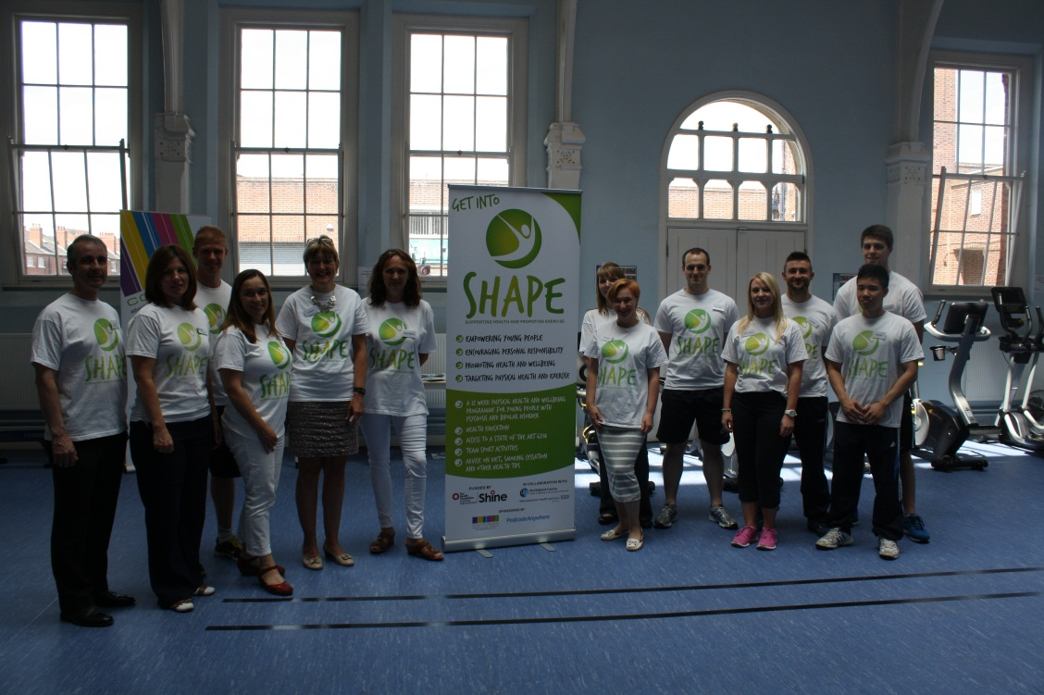

Physical health problems are common in young people with psychosis who typically have a poorer quality of life with higher rates of premature cardiovascular disease and metabolic disorders (such as Type 2 diabetes) leading to a reduced life expectancy. The mortality gap compared to their non-psychotic peers is widening and this has been primarily due to a sedentary lifestyle, poor diet composition, higher rates of obesity and smoking. Yet in many UK EI services, physical health monitoring is not systematic and care plans fail to address physical health risks.

Aims of the project
- support young people experiencing a first episode psychosis to make lifestyle choices informed by an understanding of their greater risk for obesity, cardiovascular diseases and metabolic disorders.
- provide access to healthcare in a positive and socially inclusive environment embracing the importance of ‘ordinary lives’.
SHAPE is one of the first UK ‘real world’ service evaluations of a bespoke EI physical health monitoring and intervention programme for young people with early psychosis. SHAPE employs nutritionists, exercise physiologists and health trainers and utilises student and peer group support to offer a 12-week lifestyle and exercise therapy programme in a youth focused, socially inclusive setting at the McClelland Centre for Health and Wellbeing located on the University of Worcester City Campus. The Centre has facilities including private consultation rooms, a large exercise suite with gym equipment and a meeting room. Since June 2014, we have delivered the 12 week programme to five separate cohorts of participants. To date, 27 young people have successfully completed the whole 12 week programme. We have also engaged family member support with SHAPE through a quarterly carers evening session combining a programme overview (content and facilities) with a nutrition talk and tasting session followed by an optional 3km walk using pedometers.

Physical health evaluations assessing clinical outcomes for SHAPE participants were collected at baseline (n=66), immediately post-intervention (12 weeks) (n=27) and at 12 months follow-up (n=8). Focus group evaluations and session-by-session monitoring were conducted on all cohorts to provide self-reported changes in diet and lifestyle during the programme and information about its broader impact on wellbeing and other important parameters including social isolation, confidence and self-esteem.

SHAPE has successfully engaged about half of the young people who originally elect to participate. We have explored reasons for non-participation and dropout which appear to relate to lack of motivation, travelling distance and becoming mentally unwell during the programme. Those who do engage and stick with the programme do benefit and maintain body mass, body mass index (BMI) and waist circumference at baseline levels. Some individuals have shown reductions in body mass (against an expected rising trajectory, typically 7kg in 3 months and 12kg in 12 months) and waist circumference. Our results compare very favourably with the Bondi ‘Keeping the Body in Mind’ Programme (Sydney, Australia) on which we have modelled SHAPE.

We have formed a strong interagency project team which has harnessed individuals’ knowledge and skills to benefit programme design, implementation, evaluation and promotion. We have hosted site visits for other services seeking to learn about and replicate the programme. We have secured additional EI targeted resilience funding in a joint bid with our 3 CCG partners to fund and rollout a SHAPE 2 initiative in the North of Worcestershire. The biggest challenges have been to maintain momentum in the context of staff changes, sickness and leave, and to respond to higher than anticipated levels of outside interest in the programme.

Part 2: Quality impact: outcomes

Course of the intervention, tests of change and any adjustments made.
Since June 2014, we have delivered the 12 week programme to five cohorts of participants. Physical health data was assessed at baseline, at the end of the SHAPE intervention (at 12 weeks) and at 12 months post-intervention. Focus group evaluation took place on week 12 of the programme for all five cohorts.

We have used patient feedback to inform changes to the programme for subsequent cohorts, including:
- Offering a wider choice of gym/exercise activity.
- Ensuring regular experience in the gym to increase confidence with the equipment and support longer term gym use beyond the programme.
- Reviewing the exercise programme to ensure it remains evidence based and is delivered consistently.
- Altering the nutrition sessions to make them more interactive and practical.

Primary and secondary data used to demonstrate impact on quality:
SHAPE evaluation includes:
- Key physical health risk markers including body mass, BMI, waist circumference, blood pressure, blood glucose and lipid levels.
- Self-reported fitness levels and lifestyle behaviours.
- Patient-related experience, engagement with and satisfaction with the programme and challenges/barriers to programme adherence.
- Programme engagement and dropout rates.
- Cost-efficiency.
a) What adjustments, if any, have you made to outcome measures from your original application?
Due to limitations with fasting prior to blood testing, alternative blood markers (e.g. total cholesterol and HbA1c values) were used to provide an overall picture of blood sugar and lipid levels. We have also included data on Duration of Untreated Psychosis (DUP) and length of time on and type of antipsychotic medication as moderating factors which may explain BMI differences.

b) The source of the data and how easy it is to access
Clinical data was collected by community health nursing staff as part of routine patient health checks. Additional anthropometric data, including BMI and waist circumference, was collected on week 1 and 12 of the SHAPE programme by an exercise physiologist. Programme delivery, implementation and personal impact data were recorded throughout the programme and during the focus group evaluation in week 12. Data collection for SHAPE attendees was straightforward as assessments were incorporated into weeks 1 and 12 of the programme. Follow up data for dropouts and non-attendees, at times, have been difficult to obtain; in some cases, individual case managers collected the data on our behalf. Some participants have declined blood tests.

c) The validity and reliability of the data
Data was collected at different EI clinics in which there may be differences in testing standardisation, particularly with BMI, waist circumference, which may have impacted on the rigour of the data. Wherever possible, we aimed to ensure consistent measurements by using a standardised approach to test protocols, one test technician in the same venue using the same equipment. Body mass scales with high mass limits were used to accommodate larger clients.

d) How satisfactory are your baseline numbers in terms of data quality?
Overall, we are satisfied with the overall number of patients and recognise there are some limitations of the data quality based on the ‘service evaluation’ nature of the project design.

Programme Evaluation: Preliminary Data

A: Quantitative data:

Programme engagement
Potential participants were invited from all over the Worcestershire County EI service catchment area (see Figure 1). Several individuals were travelling by public transport from the north of the County to attend the SHAPE programme; these included patients from Redditch (48 miles round trip) and Kidderminster (36 miles round trip) suggesting a high level of motivation to attend SHAPE sessions.

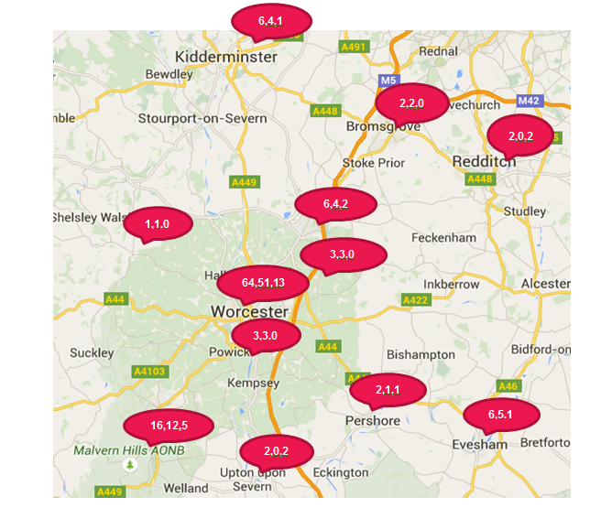

Figure 1. SHAPE programme attendance by geographical locality. The values in red represent the number of participants: invited to SHAPE (n=113), dropped out or DNA (n=86), and who completed the whole 12 week programme (n=27).

As shown in Figure 2 below, 59% (n=67) of those invited did not attend (DNA) the programme. We also identified Week 5 as a critical point within the programme where, if we can keep participants engaged up to this point, they are likely to then adhere to the programme for the programme for the remaining 7 weeks.
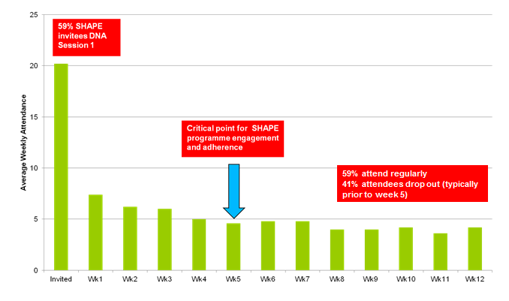
Figure 2. Mean weekly SHAPE programme attendance.

Baseline data
Mean baseline data suggests this First Episode Psychosis (FEP) population group are already at an increased physical health risk due to elevated values in resting heart rate, triglycerides (blood lipids)³, Body Mass Index (BMI), waist circumference (particularly females) and Prolactin levels (see Table 1).
Table 1. Baseline characteristics of SHAPE participants.

Variable | N | Mean (SD) | Normal range | Reference
Age (years) | 66 | 25.8 (4.9)
Males (%) | 45 | 68%
Cardiometabolic Health Measures
Body mass index (kg/m²) | 63 | 29.1 (6.3) | < 25 | Lester UK Adaptation (2014 update)
Waist circumference (cm) | ♂ 41  ♀ 18 | ♂ 93.8 (21.4)  ♀ 99.2 (12.5) | ♂ <94  ♀ <80 | International Diabetes Federation (Albierti et al., 2006)
Systolic blood pressure (mm Hg) | 52 | 121.2 (16.9) | < 140 | Lester UK Adaptation (2014 update)
Diastolic blood pressure (mm Hg) | 52 | 79.3 (13.9) | < 90 | Lester UK Adaptation (2014 update)
Resting heart rate (beats/min) | 46 | 88.2 (18.8) | < 80 | NICE guidelines
Total cholesterol (mmol/L) | 49 | 4.8 (0.9) | < 5 | Lester UK Adaptation (2014 update)
Triglycerides (mmol/L) | 21 | 2.02 (1.34) | < 1.7 | NICE guidelines
HbA1_{C} (mmol/mol) | 31 | 37.4 (8.9) | < 42 | Lester UK Adaptation (2014 update)
Prolactin (mIU/L) | 38 | 458.1 (378.4) | < 400 | NICE guidelines
Note: the red text denotes those values above or at the recommended thresholds.

At the initial health screening, 71% (n=45) were classified as overweight (BMI > 25.0 kg/m²) or obese (BMI > 30.0 kg/m²); five of whom were classified as morbidly obese (> 40.0 kg/m²). As shown in Table 2, over 50% were smoking daily and ate less than 5 fruits and vegetables a day. 52% were prescribed the most obesogenic drugs (Clozapine and Olanzapine).

Table 2. Lifestyle behaviours and antipsychotic medications of SHAPE participants at baseline.
Variable |  |  | N | % of SHAPE Participants
Currently smoking |  |  | 62 | 50% (n=31)
Alcohol use (> 1 unit) |  |  | 60 | 38% (n=23)
Drug use |  |  | 59 | 20% (n=12)
Sedentary lifestyle (< 90 min/wk) |  |  | 62 | 40% (n=25)
Unhealthy eating* (< 5 fruit+veg/day) |  |  | 59 | 64% (n =38)
Medications
Aripiprazole |  | 54 |  | 17%
Clozapine |  | 54 |  | 24%
Olanzapine |  | 54 |  | 28%
Paliperidone |  | 54 |  | 2%
Quetiapine |  | 54 |  | 22%
Risperidone |  | 54 |  | 7%
 | Note: the red text denotes those categories with high prevalence.

12 Week Post-intervention data
No significant changes in body mass, BMI and waist circumference were observed at 12 weeks post-intervention against a typical trajectory of increasing weight gain when prescribed obesogenic antipsychotic medication (Alvarez-Jiminez et al., 2012). Table 3 provides a comparison of anthropometric measurements from SHAPE with those reported for similar FEP groups from the Bondi ‘Keeping the Body in Mind’ (KBIM) physical health programme and their NSW Standard Care group in Sydney, Australia (Curtis et al., 2015).

Table 3. Comparison of mean within-group change (95% CI) between SHAPE (12 wk), Bondi KBIM study and New South Wales Standard Care (12 wk) FEP groups.
 | UK  SHAPE  (n=25) | Paired T-test data for SHAPE | Bondi  KBIM  (n=16) | New South Wales  Standard Care (n=12)
BMI (kg/m²) | 0.2 (-0.3, 0.8) | t = 0.863 p = 0.40 | 0.4 (-0.1, 0.9) | 2.6 (1.6, 3.6)
Body mass (kg) | 0.6 (-1.1, 2.3) | t = 0.717 p = 0.48 | 1.8 (-0.4, 2.8) | 7.8 (4.8, 10.7)
Waist circumference (cm) | 1.3 (-1.7, 4.2) | t =0.869 p = 0.39 | 0.1 (-2.1, 2.2) | 7.1 (4.8, 9.4)

12 month Post-intervention Data
Eight participants from Cohort 1 have completed a 12 month follow up. As seen in Table 4, there was a 5.9 cm mean reduction in waist circumference (p=0.04); no change was observed in mean BMI, body mass or any other physiological variable. Almost all patients maintained or decreased body mass, although one patient increased weight by 20 kg due to psychotic relapse (where medication levels were increased).
A positive impact on lifestyle behaviours was observed where 4 patients reported eating healthier (p=0.05), 2 ceased substance use, 1 ceased alcohol use and 3 reported less sedentary lifestyles.

Table 4. Comparison of anthropometric and physiological variables from pre- to 12 months post-intervention for Cohort 1 (includes all Cohort 1 participants who attended > 3 weeks of the SHAPE programme).
 | N | Pre-intervention | 12 months Post- intervention | 95% CI | t | P
Anthropometric Measurements
BMI (kg/m²) | 8 | 34.8 (9.7) | 35.6 (10.9) | 0.7 (-2.6, 4.1) | 0.526 | 0.62
Body Mass (kg) | 8 | 105.3 (32.3) | 107.2 (34.0) | 1.9 (-8.1, 11.8) | 0.443 | 0.67
Waist Circumference (cm) | 7 | 110.3 (29.6) | 104.4 (28.8) | -5.9 (-11.3, -0.4) | 0.971 | 0.04*
Physiological Factors
Resting Heart Rate (beats/min) | 7 | 83.0 (18.2) | 78.0 (15.7) | -5.0 (-10.2, 0.2) | -2.363 | 0.06
Systolic Blood Pressure (mm Hg) | 8 | 121.8 (22.3) | 131.8 (20.5) | 10.0 (-2.9, 22.9) | 1.836 | 0.11
Diastolic Blood Pressure (mm Hg) | 8 | 79.8 (11.1) | 77.0 (11.0) | -2.8 (-6.5, 1.0) | -1.718 | 0.13
Total Cholesterol (mmol/L) | 6 | 4.1 (1.0) | 3.7 (0.7) | -0.4 (-1.1, 0.3) | -1.505 | 0.2
Triglycerides (mmol/L) | 3 | 1.8 (1.9) | 2.1 (2.4) | 0.3 (-1.1, 1.7) | 1.000 | 0.42
HbA1c (mmol/mol) | 6 | 35.7 (5.5) | 37.7 (10.6) | 2.0 (-3.7, 7.7) | 0.907 | 0.41
Prolactin (mIU/L) | 4 | 765.5 (803.2) | 369.3 (299.4) | -396.2  (-1472.4, 679.9) | -1.172 | 0.33

B; Qualitative data:

Programme Engagement
Programme adherence was monitored by keeping session-by-session attendance and recording patient’s reasons for non-attendance and disengagement (see Figure 3).

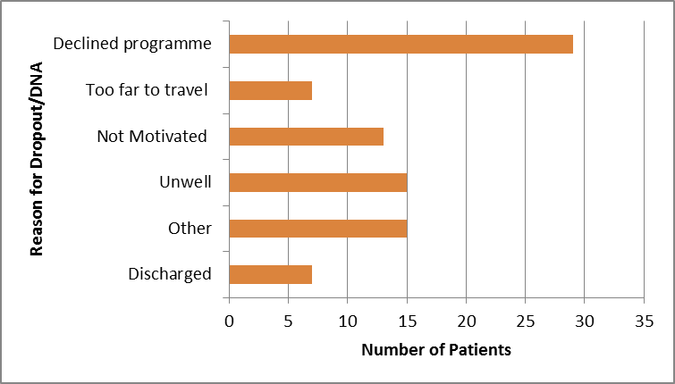
Figure 3. Patient’s reasons for not attending (DNA) or dropping out of SHAPE programme (data available for n=86).

Focus Group Evaluation
Focus group evaluation takes place in week 12 and additional informal programme feedback is collected weekly. Data from the focus groups has been subjected to thematic analysis, with a ‘constant comparison’ of themes across cohorts. Evaluation themes included (see Appendix 5 for further quotes):

- Getting Started: social support; why not! (nothing to lose, feelings prior to attending); motivation; volition; and normalising (feeling normal).
“…when people started to talk to me, and I started to talk back to them, it was easier because I felt like I’d made a friend, and then more friends, and it was easier than just being on your own, because you felt like you were going with somebody.”
“It’s more of a relaxed environment here I guess, because it’s not as busy as some gyms can be. It’s a bit smaller as well. You’re in control of what you’re doing, and it’s just a good experience.”

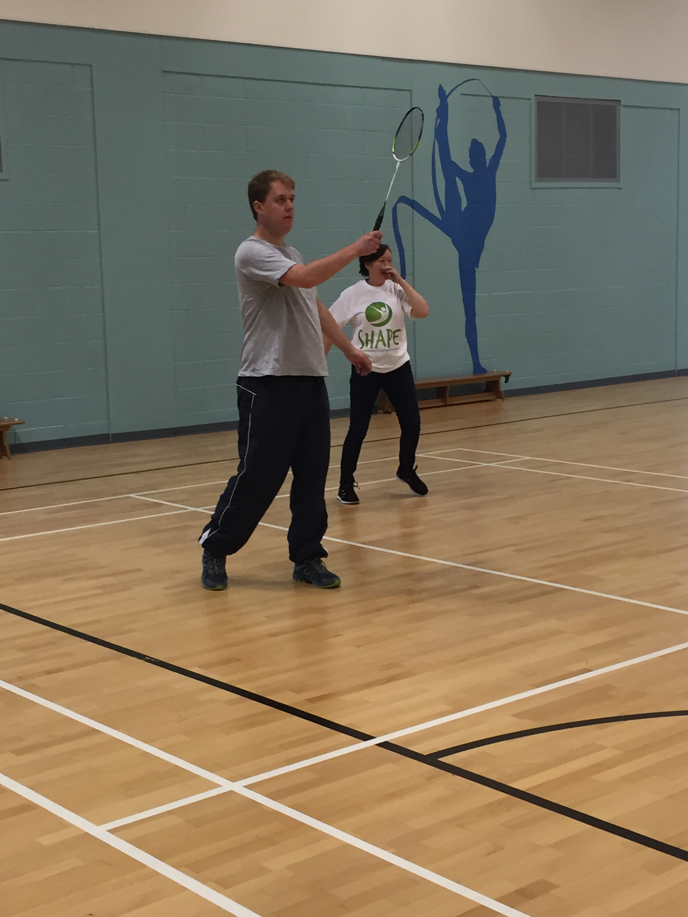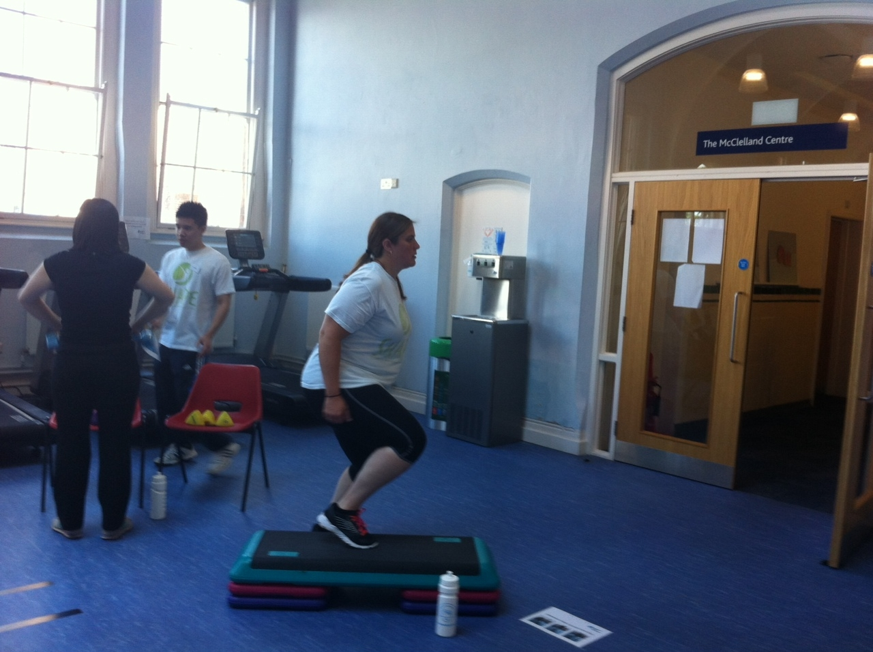

- Maintenance: structured activities; gaining confidence; applying new knowledge
“Every week was different…It wasn’t the same old thing, it was very varied.”
“The books help that we’ve got. It was good because it was something else to focus on, and to try things that you wouldn’t ordinarily try.”
“The sessions have been worthwhile and I have gotten more fit and I have lost weight.”

- Feedback: programme feedback; family engagement; and support
"nothing was said in a way of kind of dictator kind of a way it was kind of an open discussion on options we have over our lifestyle rather than like “you’re not eating this or you’re not eating that or get out and do that!” it was more of make your own decisions based on our recommendations…which was good.”

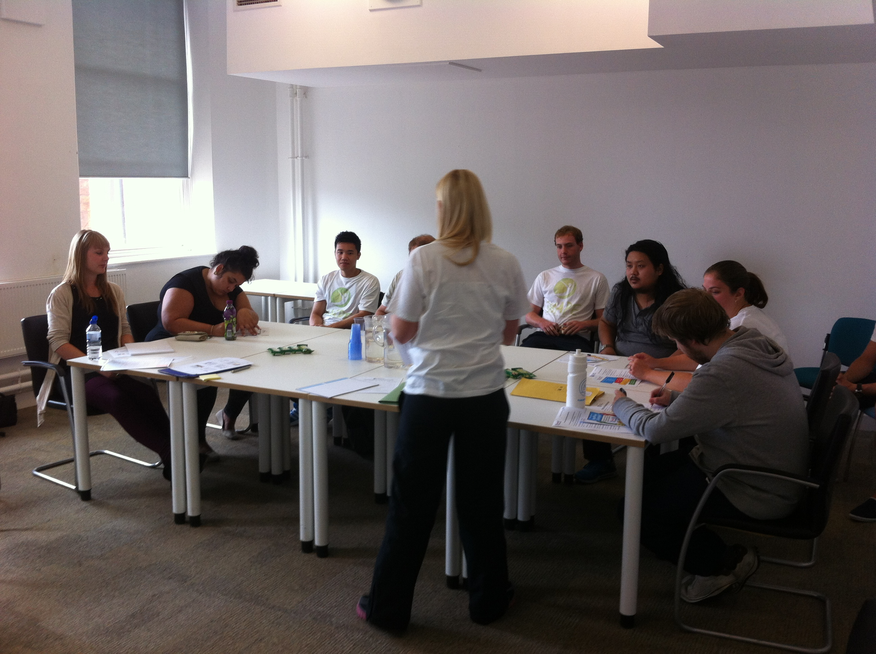

We do not formally seek family members views on the SHAPE programme impact. However, we recently received the following very positive feedback from a mother of a SHAPE participant::

'SHAPE has probably changed X's life. I had long been worried about X physical health as he used to be an athlete and incredibly strong in his student days. His interests included mountain climbing and hiking. The medication he is on now heavily sedates him so he sleeps most of the day and he had put on a lot of weight (nearly 20 stone at one stage). He was also very weak so reluctant to even walk anywhere. When his Psychologist first suggested SHAPE, X was very against the idea but he did start exercising at home and began losing weight...and eventually X agreed to give SHAPE a try. He hasn’t looked back. It has just transformed him. Not only is he back in shape – almost to his old self – but he is so much more positive and confident. He has enjoyed all the different activities and is interested in the nutrition advice. He is taking much more interest in his own wellbeing which is what SHAPE is about – not just the exercise. He is looking good so we have been clothes shopping and he taking an interest in how he dresses. This has been wonderful to see. He was very nervous of meeting new people and being in unfamiliar surroundings but immediately felt so supported that his fears vanished. Everyone is so friendly and kind. Someone even met him along the way to the centre. He is naturally a sociable character with a great sense of humour which he was losing with spending so much time on his own so that has been of great value as well – he is back to his old self. When we went to the evening meeting at the end of the course. I was impressed with how relaxed and chatty he was. The 12 weeks are up but he remains just as motivated which couldn’t be better illustrated by the fact that he, and another fellow on the course, are keeping up the same routine and are still going to the centre. From my point of view, SHAPE has given me my son back. Long may it continue'.

Impact to date against original intended outcomes:
This first year of piloting has tested the feasibility and acceptability of SHAPE and evaluated the physical health and wellbeing benefits for participants. to date, the evaluation has shown that young people with psychosis can reduce or delay their physical health risk following a 12 week exercise and lifestyle intervention and these benefits appeared to be sustained over a 12 month follow up. The majority of those who completed the SHAPE programme maintained their weight following the programme and reported lifestyle behaviour changes including a reduction in substance use, improved diet and regular engagement in physical activity (> 90 min/wk). Approximately 25% of those invited to attend subsequently engaged in the programme. Those who attended commented very positively about programme content, peer group experiences, support from SHAPE staff and valued the University setting. Participants also appreciated regular access to clinical and fitness staff, exercise, nutrition and overall care advice and physical health assessment. Participants reported a positive impact of the SHAPE programme on their general wellbeing including physical, social and mental health as well as day to day functioning. Family member and support worker feedback on the SHAPE programme has been very positive.

Part 3: Cost impact

Key Cost Measures and Financial Impact
Currently, we are limited in our ability to provide an accurate financial impact assessment based on the 12 month evaluation data for two reasons: 1) the programme aims to prevent future risk and use of acute and specialist diabetes and CHD services over decades where care costs data is not available yet for mental health populations: and 2) we do not have data from a matched FEP control group for immediate data comparison with SHAPE outcomes.
However, key cost measures that can be used in a future SHAPE programme cost evaluation include:
- percent change in body mass (McQuigg et al., 2008) and subsequent improvement in quality of life years (QALY), where the cost of Quality of Life Years has been shown to reduce if patients can (a) avoid 7% weight gain and (b) stop smoking (NICE CG178). A sample data comparison using data from the KBIM study 'Standard EI Care' control group is presented in Table 5.
- percent change in prevalence (based on BMI change) of CHD and Type 2 diabetes (Lewis et al., 2014). A sample data comparison using data from the KBIM study 'Standard EI Care' control group is presented in Table 6.
- reduction in clinical contact hours and hospital admissions (e.g. a reduction of 6 patient contacts/week would equate to a saving of £112.50/week)
- cost avoidance based on changes in lifestyle behaviours including cessation of smoking, substance use and excessive alcohol consumption.
Although there are limitations with our comparative care control group sample, using data taken from the 'EI Standard Care' group reported in the Bondi KBIM Programme group study publication (Curtis et al 2015), the data in Table 5 suggests that the SHAPE intervention has diminished the percentage BMI increase (1.8% vs 10.2% BMI rise) which will have a positive impact on QALY costs. Table 6 data shows a lower % change in prevalence for type 2 diabetes and CHD for SHAPE (12 month) data compared with the NSW 'EI Standard Care' group (12 week) data which suggests that the SHAPE intervention may also have reduced the potential for an increased prevalence for type 2 diabetes and CHD and their associated care costs.

Table 5. Change in body mass index.
BMI group (kg/m²) | N |  | Pre- SHAPE |  | 12 months Post- SHAPE |  | 12-month change in BMI |  | % change in body mass^{ǂ}
SHAPE Cohort 1 |  | 8 |  | 34.8 (9.7) |  | 35.6 (10.9) |  | +0.8 |  | +1.8%
NSW EI Standard Care |  | 12 |  | 24.8 (3.3) |  | 27.4 (3.1) |  | +2.6 |  | +10.2%
ǂ Cost of quality of life years (QALY) has shown to be reduced if patients can (a) avoid 7% weight gain and (b) stop smoking (NICE CG178).

Table 6. Prevalence of co-morbidities: type 2 diabetes and Coronary Heart Disease (CHD) based on BMI change.
BMI group (kg/m²) | N | Type 2 diabetes  Prevalence |  | Percent change in prevalence of Type 2 diabetes | CHD  Prevalence |  | Percent change in prevalence of CHD
 |  | Pre | Post |  | Pre | Post
SHAPE Cohort 1 | 8 | 10.54% | 11.2% | +0.7% | 6.98% | 7.21% | +0.2%
NSW EI  Standard Care | 12 | 4.62% | 5.72 % | +1.1% | 4.10% | 4.85% | +0.8%
Note: the SHAPE Cohort 1 data is 12 months post-intervention and the NSW EI Standard Care data is 12 weeks post-intervention. However, without intervention, we would expect the NSW EI Standard Care group to show additional weight gain over 12 months based on the weight gain projections in FEP over time reported by Alvarez-Jimenez et al. (2008).

Estimated Costs of Existing Services

Prior to the SHAPE project, the Worcestershire EI service did not offer consistent physical health monitoring provision or intervention, this was due to lack of staff time and provision, and no additional financial budget (or costings) allotted for this service. Due to recent changes in the NICE Quality and Standards 6 & 7 and the Care Quality Initiative which states that physical health monitoring for both inpatients and outpatients with a Severe Mental Illness (SMI) including FEP is required, the EI service began seeking funding support to enable this provision.

Financial Costs of SHAPE
The Shine 2014 funding award has been used to support SHAPE content development, programme design, implementation and initial evaluation of the intervention (see Appendix 1). A costs/gains diagram summarising SHAPE programme 'inputs', 'activities'. 'outputs' and 'outcomes' is detailed in a table in Appendix 4.

Implementations costs of Intervention
Future NHS delivery of the SHAPE intervention has been projected based on a ‘streamlined’ program delivery and implementation to 4 accessible locations within the County/region. It is expected that the programme will be offered to a wider range of patient populations within the mental health services which will reduce the overall programme costs per person. Using this proposed model, we would aim to deliver sessions to 4 cohorts per year at 4 locations simultaneously within the County/region. We project that total set up cost and annual delivery of the programme to a specified region (total reach = ~125-150 patients) would cost ~£37,196 at a cost of £247.97 - £397.56 per person per annum. This model would allow for sustainable delivery and for SHAPE to be delivered as one element in an integrated NHS mental and physical health care package.

Implementation costs per region would include staff training, recruitment of an appropriately trained staff member to lead the programme, SHAPE package and materials, venue costs, guest speakers for the educational sessions and staff transport costs. Costs accrued ‘in kind’ would include 1) a physical health champion positioned within the community mental health team that would engage, refer and complete physical health checks (no additional costs as this would be included in the standard physical health pathway); and 2) peer support workers to support participants during the programme.

Part 4: Learning from your project

We achieved all that we set out to achieve and more. The project has had a dual positive impact on the young people who successfully completed the programme and the SHAPE team responsible for delivering the programme. There has been a high level of interest in the project from services across the country and internationally, as well as positive publicity and national and international opportunities for dissemination.

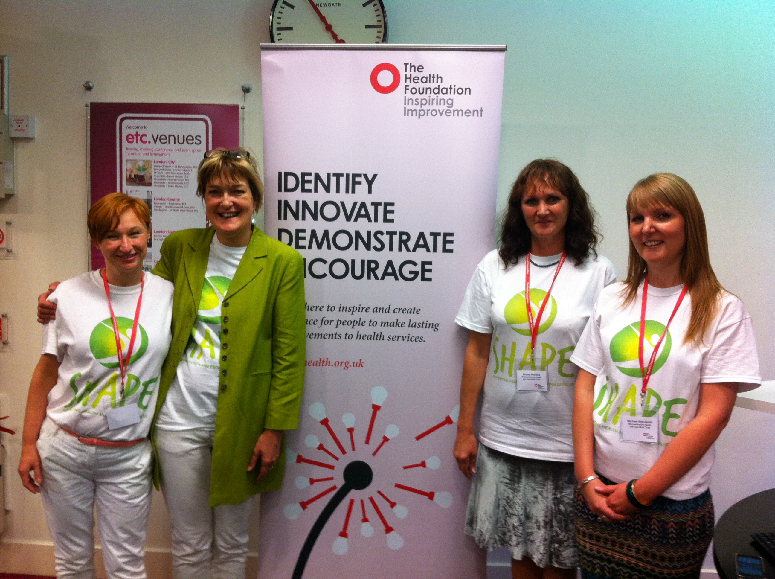

The NHS and University partnership has been a significant enabling factor. The multi-professional team has resulted in the provision of a programme with high levels of clinical expertise, skills and support, alongside teaching excellence (exercise physiology, nutritional therapy) and high quality evaluation (project design, assessment and data analysis). The commitment and enthusiasm of the project team has supported us to develop an evidence-based programme, grounded in clinical and academic expertise and shaped by participant feedback. Working together has provided multiple opportunities for learning and reflection. Both the Trust and University recognised the programme to be an important priority for staff involved in its delivery and evaluation. The SHAPE team held regular project meetings which supported us to retain enthusiasm and momentum.

The project lead continues to be actively involved in a range of relevant FEP and physical health networks, communicating with academic and clinical contacts from across the world. This has increased our opportunities to feedback progress and findings at prestigious national and international conferences and meetings (e.g. Rethink Psychosis summit in London, International Early Psychosis Association Conference in Tokyo, British Association for Pharmacology Guideline meeting in London and iPHyS international physical health in young people collaborative meetings in Padua and Tokyo). Other team members have utilised their clinical academic links to share findings through posters and presentations at regional and local seminars and research collaborative events.

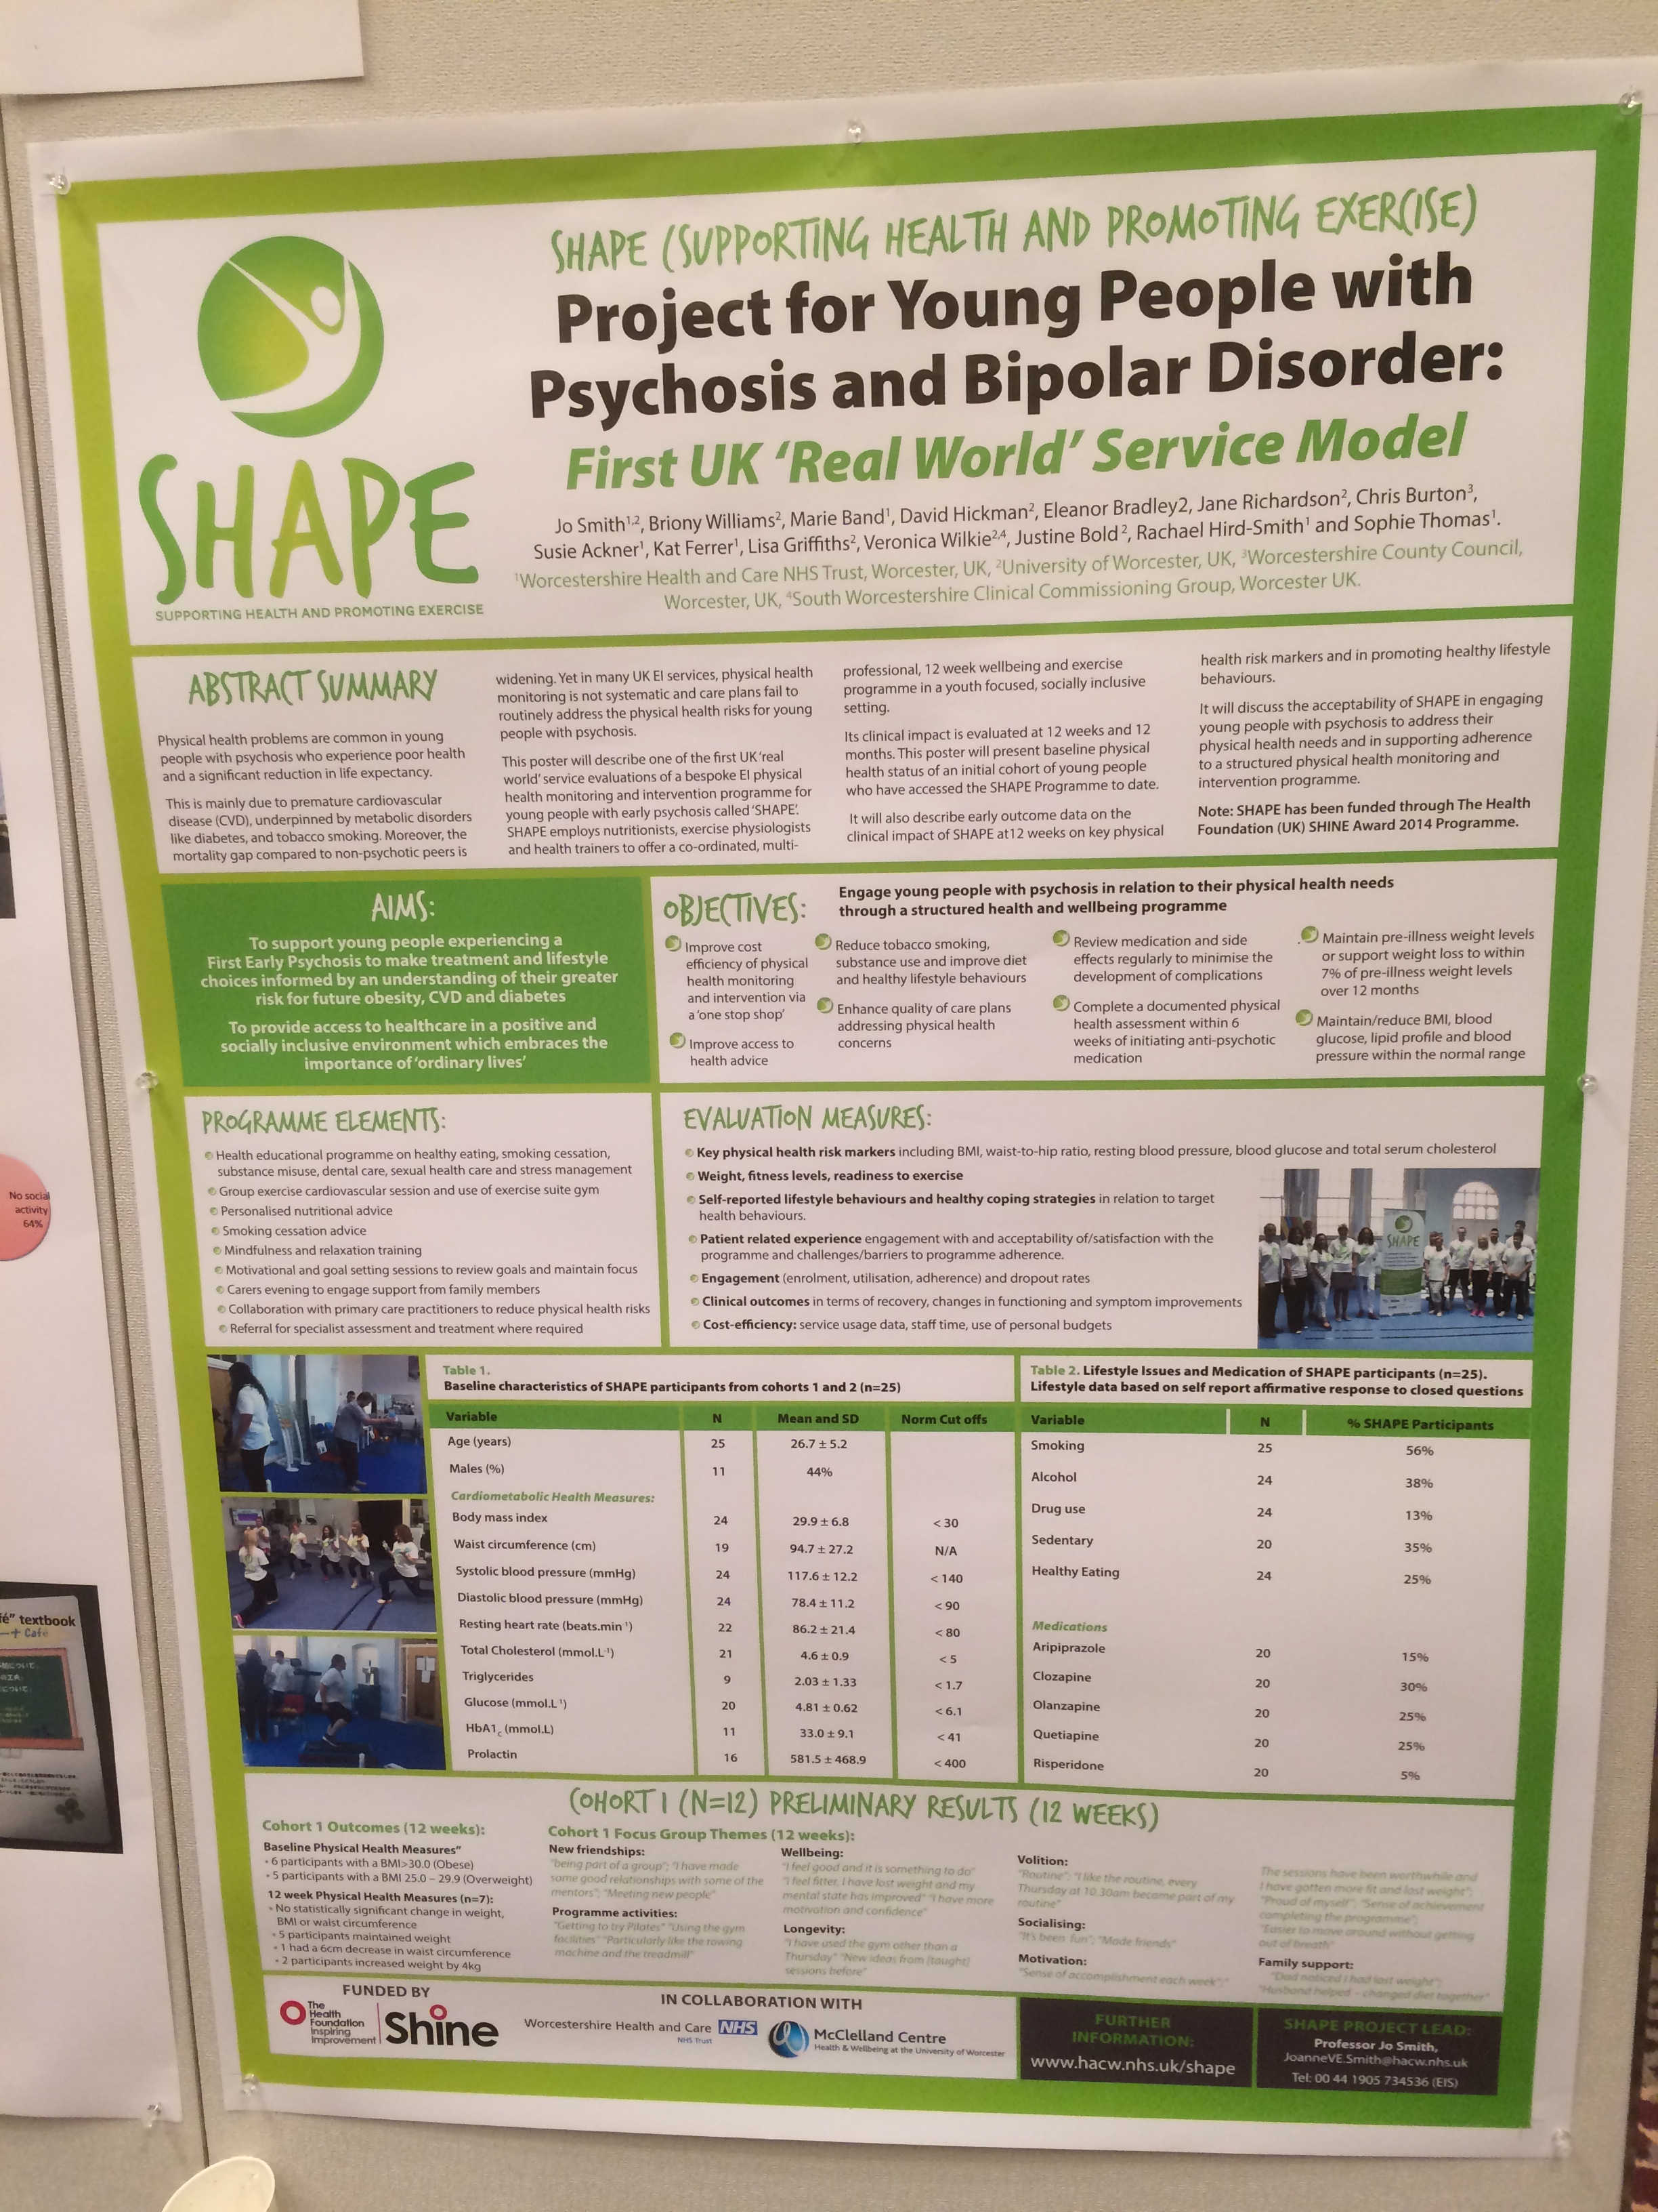

Recruitment to the programme has been a challenge, but has been overcome by the presence of enthusiastic team members within clinical services promoting the programme to potential participants and staff members. Clinical input has been essential to support the collection of baseline data, as well as to highlight the importance of physical activity and health promotion amongst this particular group of young people with clinical colleagues.

Once young people were engaged in the programme, the availability of a varied range of taught sessions and group activities enhanced satisfaction and played a role in reducing drop-out. Including the Earn As You Learn (EAYL) students in gym and exercise sessions was particularly helpful in supporting a youth-focused approach as participants were ‘buddied up’ with similarly aged students who encouraged attendance and whose presence helped to normalise gym and sports activities. This provided unintended mental health awareness opportunities for the EAYL students who participated and helped to reduce the stigma and social isolation experienced by participants particularly in relation to contact with a non psychotic peer group.

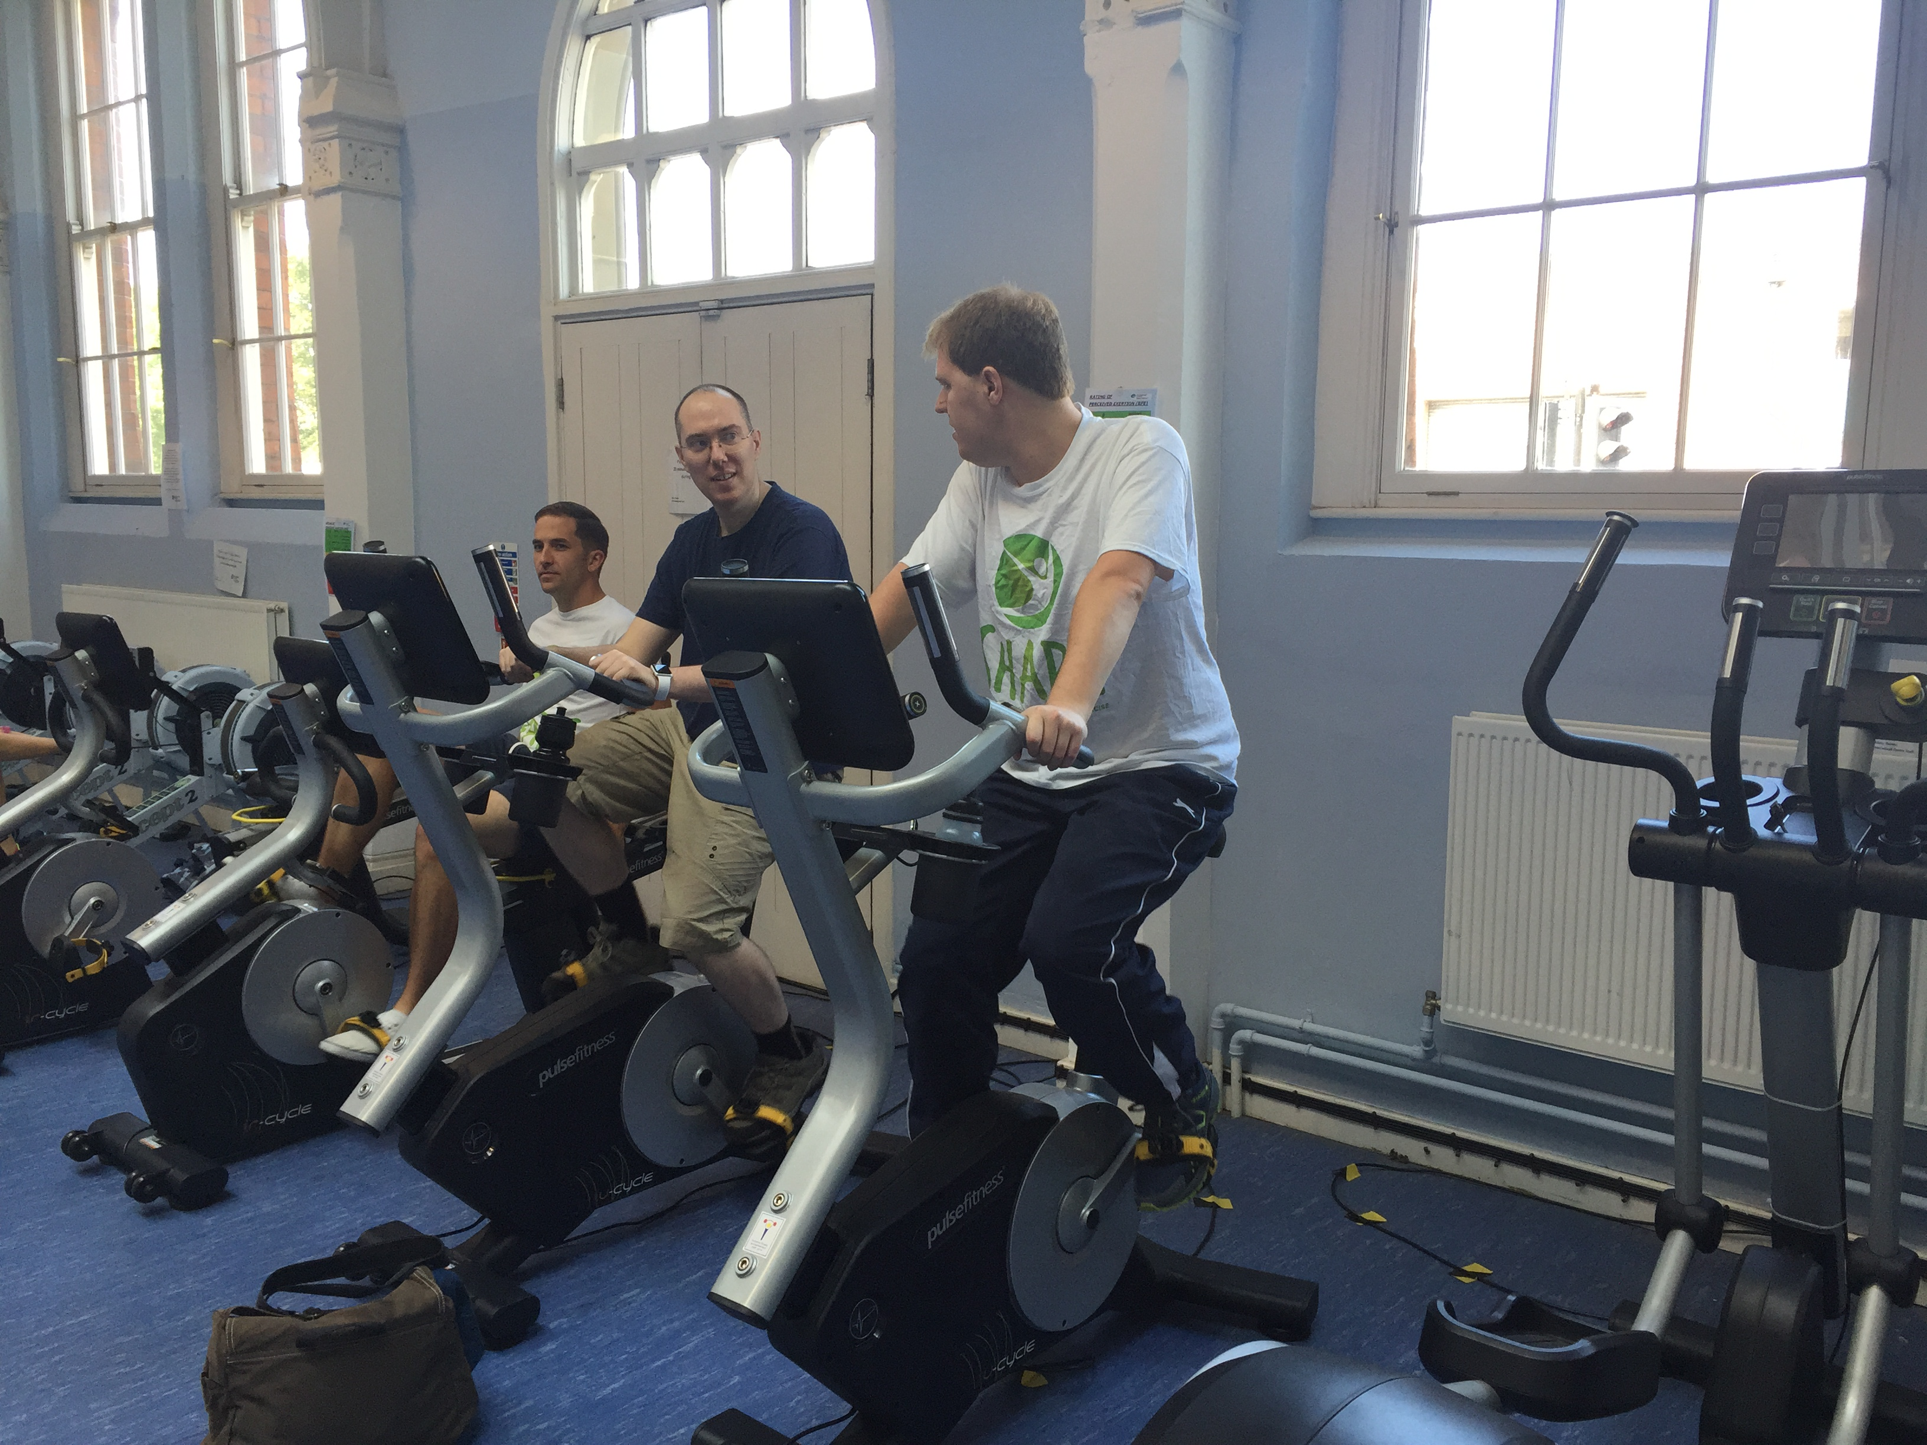

Qualitative feedback suggests a number of health promotional benefits from the programme, beyond increasing physical activity. The provision of interactive nutrition sessions, including healthy food 'sampling' sessions, has encouraged participants to try new foods and think about accessible changes to their diet. In addition, the group based delivery of the programme has reduced social isolation and encouraged social contact between participants both within and outside of the formal SHAPE sessions. The programme has also led to reported benefits in relation to confidence, social anxiety, identity and self-esteem as well as a broader impact on day to day functioning and mood on other days in the week.

Challenges
Key challenges we faced were associated with the population we were striving to engage, rather than organisational, policy or team challenges. Young people with psychosis can experience many difficulties associated with their mental health including psychotic symptoms, social anxiety and poor motivation. For some young people, the prospect of a group-delivered programme was particularly daunting. 59% of individuals who were invited to participate did not attend the first session due to lack of interest, poor motivation, poor mental health or concerns about travel. Recruitment to the programme required team members to spend time sharing information and promoting the programme with young people and staff members. The workload associated with this was significant and required clinical team members to prioritise SHAPE involvement alongside other clinical roles and duties.
To overcome these challenges we employed the following strategies:
- Encouraged clinical staff to provide additional support to those young people who felt particularly anxious prior to the first session.
- The EAYL students were deployed in the waiting area in the main reception to provide support and directions when participants arrived to attend the SHAPE programme.
- As young people progressed through the programme, ongoing support and clinical expertise was required for some participants to encourage them to continue.
- Although drop-out was expected, and the drop out levels from SHAPE are consistent with the expected drop-out from gym attendance across other populations, work will continue to evaluate whether the SHAPE workbook could be utilised further to decrease drop-out and encourage maintenance of behavioural changes at 12 months.
- We selected a central accessible city centre location for the programme, with good public transport bus and rail links (The McClelland Centre on the University of Worcester City Campus site). However, as participants were drawn from across a geographically large and very rural County, travel time and a poor public transport infrastructure particularly in more outlying areas of the County remained a barrier for some potential participants.
We achieved our original ambitions, but participant recruitment was a significant challenge throughout the programme. As the programme develops, the ongoing commitment of EI staff is vital to share information about the programme and to provide encouragement to those young people who show an interest in participating. Suitable venues, which are youth-focused, non-stigmatising and accessible are essential and require good organisational partnerships to enable programme delivery.

Introducing and sustaining innovation in the NHS

Setting-up a new programme is time intensive and we learned a great deal through this period. To share this learning with others and promote long-term sustainability from our SHAPE experience, we plan to put in a bid for additional Health Foundation Shine 2015 Spreading Improvement funding to develop a programme handbook, which will include the programme plan (weekly exercise sessions and activities), participant workbook, SHAPE programme manual (handouts and PowerPoint slides from the educational sessions) and key areas of advice based on our learning (‘top tips’). The handbook will be designed to provide others with essential information and programme support to establish and deliver SHAPE elsewhere in the County and beyond. The SHAPE team are already currently involved in establishing a SHAPE 2 programme in the North of the County in a partnership with a local FE College gym and staff. This will allow us to field test an initial programme handbook and identify key information and resources (staff, equipment, facilities) required for set-up and implementation to be incorporated in a comprehensive SHAPE programme support package that can be shared with others interested in replicating SHAPE elsewhere.

Doing things differently

There are a number of points we would be keen to consider whilst developing this work and encouraging others to take on similar projects. These include:-
- The appointment of peer support workers who have completed the SHAPE programme to provide support to new participants, particularly at the first session.
- Enhanced engagement with secondary care to increase referrals to SHAPE.
- Active engagement with primary care to ensure the documentation of accurate baseline physiological measures.
- Provision of awareness raising sessions with mental health professionals focusing on the importance of physical health and their role in promoting good physical health (including comprehensive repeat physical health assessment and monitoring).
- Collaborative working with Public Health colleagues to identify areas of local need and disseminate good practice findings.

Part 5: Plans for sustainability and spread

The SHAPE programme will be sustained and developed beyond this initial funding period. South Worcestershire CCG has provided time limited funding for 12 months to establish and trial a new programme (SHAPE 2) in the north of the County. This programme will be run to the same specification as SHAPE. The intention is to increase the numbers of young people with access to the SHAPE programme and to promote the programme to new clinical teams and services. In addition to access, the cost efficiency of the programme will be improved if access is opened up to encourage participation from a wider CMHT patient group in addition to those invited from local EI teams. Availability of the programme in different parts of the County will support services to provide a consistent approach to physical health care planning when addressing the physical health needs and risks for young people with psychosis.

There is a commitment from the University of Worcester to continue the collaborative partnership and support the on-going delivery of the SHAPE programme (through ongoing availability of EAYL students) and evaluation (through academic input). A new SHAPE cohort (cohort 6) is being recruited and the programme will continue to run in the McClelland Centre building. The evaluation project will be developed into a new research project, utilising and building on findings from the existing SHAPE service evaluation.

To spread this innovation further, the team are developing a robust argument for commissioners, service leads and clinicians which will utilise the findings from SHAPE to emphasise the benefits of engaging young people with first episode psychosis in physical activities, including providing a full cost-benefit analyses, as well as promoting the essential role of physical health assessment and monitoring. In addition to the benefits for young people themselves, this would support local services to meet essential quality standards included in national CQUIN targets and NICE Guidance for psychosis (2014) as well as concordance with new EI Access and Wait Times (AWT) 2015/16 policy requirements. A business proposal to provide longer-term funding for SHAPE has been included in the local Trust Business Plan 2015/16 and is being considered by senior managers and local Commissioners. Work will continue in partnership to explore different options to sustain the programme, including a bid for SHINE 2015 Spreading Improvement funding to develop and produce a SHAPE programme handbook and associated marketing information.

There has been a large amount of interest in SHAPE regionally, nationally and internationally (see appendix 2).

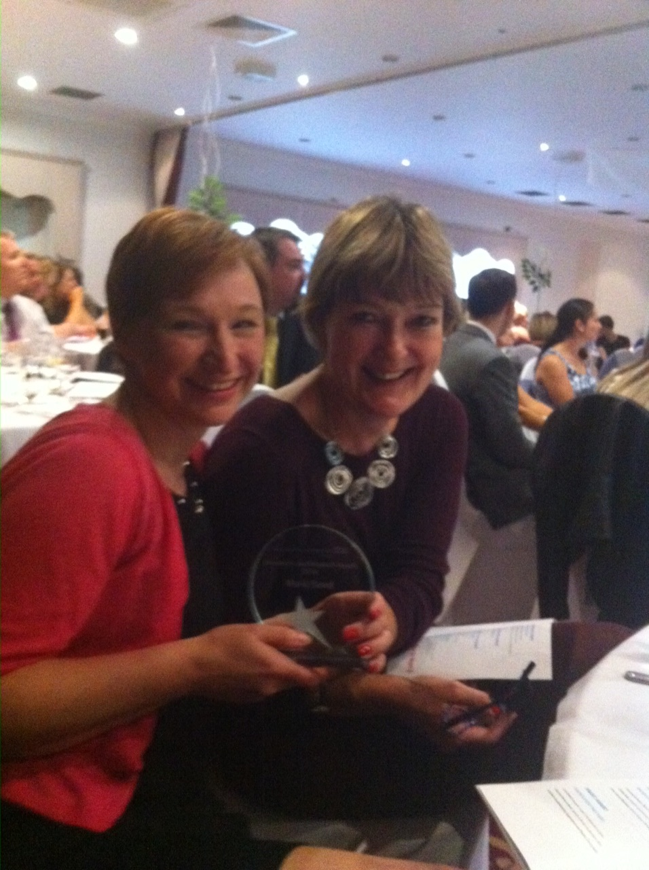

The SHAPE project has been shortlisted for a prestigious Health Service Journal (HSJ) 2015 'Innovation in Mental Health' award where we are a finalist from a pool of over 1600 other project nominations. In 2014, the SHAPE Project Lead was a finalist in the HSJ 2014 'Clinical Leader of the Year' category based on her work in leading SHAPE alongside other innovations for young people with psychosis and their families. The SHAPE Clinical Lead received a Worcestershire Health and Care Trust 2014 Staff Innovation Award for her work in establishing the SHAPE programme. SHAPE has been used as an example of good practice within the new EI Access and Waiting Time (AWT) 2015/16 policy guidance (to be published end of September 2015) and new British Association for Psychopharmacology (BAP) Guidance on ‘Managing Metabolic Disturbance with Antipsychotic Medications for Schizophrenia’ (to be published later in Autumn 2015). SHAPE has also been included as a good practice case example by the NHSIQ Living Longer Lives CVD Prevention and the RETHINK Mental Health Innovation Network Programmes. Team members have attended a wide range of national and international conferences and learning events to showcase SHAPE and our initial service evaluation results (see appendix 2).

Appendix 2: Resources from the project

Shape Resources:

There is a SHAPE website and a couple of short promotional films showing the SHAPE Programme in action:

- SHAPE video (full length 12 minute version): http://youtu.be/DyAS3AaSzWo
- SHAPE video (short 5 minute version): http://youtu.be/NnZCCbd9_DA
- SHAPE website: www.hacw.nhs.uk/shape

There is also a SHAPE published case example for the NHS IQ Living Longer Lives CVD Prevention Programme http://www.nhsiq.nhs.uk/media/2582868/shape-case-study.pdf

SHAPE Articles/Media releases and Blogs:

- Press articles about the SHAPE project were published in local newspapers: Worcester News and Stourbridge News (May 2014).
- SHAPE website developed and located on the Worcestershire HACW NHS Trust website: www.hacw.nhs.uk/shape
- A SHAPE Promotional video 1 link was developed in conjunction with our Trust Comms Team and uploaded to view on YouTube and the link shared with key stakeholders and commissioners (July 2014).
- SHAPE mentioned as the first UK pilot in a Guardian Society news article about Bondi Keeping Body in Mind Physical Health Programme (Guardian: 30th July 2014).
- Postcode Anywhere published a blog about the SHAPE Launch event (July 2014).
- Concept Design released a blog following the SHAPE Launch Event (July 2014).
- SHAPE included in ‘Healthy Worcester’ Health and Wellbeing Plan 2012-2016 (September 2014).
- SHAPE mentioned in Schizophrenia local press article for World Mental Health Day (10th October 2014).
- BBC Hereford and Worcester radio interview about SHAPE with a SHAPE participant (24th October 2014).
- Information about SHAPE provided at the World mental health day event where the theme this year was 'Living with Schizophrenia' (10th October 2014).
- Worcestershire Health and Care NHS Trust Press release about the ‘Parity of Esteem’ event where Jo and Marie presented on SHAPE (October 2014).
- Press release about the ‘Parity of Esteem’ event where Jo and Marie presented on SHAPE released in the Bromsgrove Advertiser (October 2014).
- The Parity of Esteem Event presentations including SHAPE was filmed and put on to the Worcestershire Health and Care NHS Trust website(24th October 2014).
- Jo Smith, SHAPE Project Lead, nominated, shortlisted and a finalist in the HSJ 'Clinical Leader of the Year' Awards 2014
- Article about SHAPE and its potential for similar programmes to be run in the County in the future was released in the Redditch Standard (November 2014).
- SHAPE included as a case study on the NHS IQ ‘Living Longer Lives’ CVD prevention Programme and published on the NHS IQ website (December 2014) and promoted at a NHS IQ national learning event (April 2015).
- Postcode Anywhere published a blog about SHAPE in regards to the pedometers they funded for the programme participants (Dec ember 2014).
- Concept Design released a blog about SHAPE presenting at the IEPA conference in Japan as they were key in the final formatting of the poster which was presented (January 2015).
- A SHAPE Promotional video 2 link was developed in conjunction with our Trust Comms Team and a shorter 5 minute version were both uploaded to view on YouTube and the link shared with key stakeholders and commissioners (January 2015).
- Article about SHAPE in Worcestershire Health and Well-being Board Obesity Action Group Newsletter circulation includes district councils, sports clubs and CCGs (January 2015)
- SHAPE invited to submit a proforma to be included as a NICE Local Practice case example (March 2015)
- SHAPE included as a case study on the RETHINK Mental Health Innovation Network Programme (June 2015) and will be promoted at a RETHINK Mental Health Innovation Network National Learning event (October 2015).
- SHAPE included as part of the Worcestershire EIP Service good practice case example to be included in the EIP Access and Wait Times Commissioning Guidance (September 2015)
- SHAPE included in British Association for Psychopharmacology (BAP) Guidance on ‘Managing Metabolic Disturbance with Antipsychotic Medications for Schizophrenia’ (to be published later in Autumn 2015)
- SHAPE nominated for HSJ 'Innovation in Mental Health ' Award 2015

Future Plans:

- SHAPE Programme awards ceremony (date TBC)

SHAPE presentations:

- The International Physical Health in Youth Stream (iphYs) International Seminar and Working Group Meeting- University of Padua, Italy (4th April 2014)
- National Psychosis Summit in London (10th April 2014)
- Worcestershire Health and Care NHS Trust Senior Leaders Away Day: project video clip (16th April 2014)

Worcestershire Health and Care NHS Trust Research Day (7th May 2014)

SHAPE launch event (10th July 2014)
- Presentation at WCC “Healthy Worcester” Meeting (21st August 2014)
- SHAPE Carers evening (21st August 2014)
- Research seminar at South Staffs and Shropshire Healthcare NHS Trust to encourage further West Midlands dissemination (24th September 2014).
- SHAPE participant presented at the Worcestershire Health and Care Trust Board Meeting (October 2014)
- Worcestershire HACW NHS Trust led ‘Parity of Esteem’ Event for Trust members , staff and other stakeholders (24th October 2014).
- International Early Psychosis Association Conference in Tokyo, Japan: poster and a paper within a physical health in FEP symposium (17th and 19th November 2014 respectively).
- BBC Hereford and Worcester radio interview about SHAPE with a SHAPE participant (24th October 2014).
- Information about SHAPE provided at the World Mental Health Day event where the theme this year was 'Living with Schizophrenia' (10th October 2014)
- British Association of Psychopharmacology (BAP) Guideline Scoping Meeting on the management of weight gain and metabolic disturbances associated with psychosis and antipsychotic drug treatment at the Hallam Conference Centre, London (16th January 2015)
- BMA meeting on ‘Health Inequalities in Schizophrenia’: joint presentation on Parity of Esteem agenda using SHAPE as a case example with Dr David Shiers (GP and clinical advisor to the National Audit of Schizophrenia)at BMA, London (20th January 2015).
- University of Worcester Human Health and Wellbeing Research Strategy meeting (19th January 2015)
- Scottish Royal College of Psychiatrists Meeting Presentation by David Shiers including SHAPE slides (30th January 2015)
- Carers evening presentation (25th February 2015)
- NHS Health Scotland Event Improving Physical Health Outcomes of those with Severe and Enduring Mental Health Problems, Glasgow: Presentation by David Shiers including SHAPE slides (4th March 2015)
- NHS IQ National Learning Network event in London to share learning from the CVD SMI pilot project and look at how services can improve the CVD health of people with a SMI; invitation to run a breakout session on the SHAPE Programme (29th April).
- Treating Schizophrenia 2015 9th National Conference Psychiatry and Physical Health Conference, London (1st May 2015).
- NHS IQ National Learning Network webinar event on SHAPE (19th May 2015)
- Norwegian Early Psychosis Annual Conference: Physical Health Symposium (2nd June 2015).
- Daynor Spurr (TEES, ESK AND WEAR VALLEYS NHS FOUNDATION TRUST) presenting SHAPE -weight management groups for people with mental health problems. Dietetic Conference in Dublin (22nd May 2015).
- Dr Tara Walker and Dr Sally Natynczuk presented a poster at the Royal College of Psychiatrists International Congress, 29 June – 2 July 2015, Birmingham
- David Shiers presented Shape outcome data on our behalf at an NIHR Mental Health National Scientific Meeting on Improving Mental Health Care in York (25th February 2015),
- David Shiers presented Shape outcome data on our behalf at an NHS Scotland meeting on Improving Physical Health Outcomes of those with Severe and Enduring Mental Health Problems in Glasgow (4th March 2015)
- David Shiers presented Shape outcome data on our behalf at a 'Mental Disorders and Metabolism' symposium) at the 23rd European Congress in Psychiatry in Vienna Austria (29th March 2015)
- Manchester CLAHRC GM Physical Health and Mental Health Festival , Manchester with Dr David Shiers (15th June 2015)
- Worcestershire Research Collaborative: Helen Lester Memorial Lecture with Dr David Shiers (25th June 2014)
- British Dietetic Association Mental Health Group Annual Conference, Teesside University (30th June 2015)
- David Shiers presented Shape outcome data on our behalf at the 'Wales Early Psychosis - the way forward' learning event, Wales Centre for Mental Health Services Development , SWALEC Stadium, Cardiff (7th September 2015)
- Carers evening presentation (10th September 2015)
- AQUA Improving Access and Experience for people with First Episode Psychosis - North West EI Teams Community Event, Bolton (16th September 2015)

Future Presentation Plans:

- Rethink Innovation Network Event, London (25th September 2015)
- Creating Clinical Excellence in Worcestershire, University of Worcester (28th October 2015)
- International Early Psychosis Association Conference in Milan, Italy (20th-22nd October 2016).
- The International Physical Health in Youth Stream (iphYs) International Seminar and Working Group Meeting- Milan, Italy (October 2016)
- Improving Physical Health. NMP CPD at the Chateau Impney (March 2016)
- Postcode Anywhere fundraising event to raise awareness of and additional funds for SHAPE (date TBC).
- RCN Quality Innovation Conference West Midlands(11th November)

Appendix 3: SHAPE Programme Example
Date | Week | Presentation  Session  CHLG031 | Exercise Therapy | Activity
 | 10.30 | 10.30 | 11.15
25th June | Week 1  Getting Started | Rachael  Introduction/consent  Lisa  Baseline Data Collection | Richard/EAYL  Why exercise? Impact on medical condition? | McClelland Centre  Gym Introduction – Orientation to equipment  Allocate EAYL to participants  Richard/EAYL
2nd July | Week 2  Get Moving | David  -Readiness to change/motivation  Goal setting | Richard/EAYL  -Benefits of aerobic exercise and cross-training.  -Safe use of equipment. | McClelland Centre  -CV equipment  -Supervised weights session  Richard/EAYL
9th July | Week 3 | Rachael/Marie  Talk about ethics/ gain consent  Walk to arena | Half-time session about play and PA and other sports they can engage in. | Riverside/Arena  Badminton/  Basketball  Arena  Richard/David EAYL
16th July | Week 4 | Justine Bold  Healthy Eating 1  Portion Sizes | McClelland Centre  Body Balance  James/EAYL | McClelland Centre  Body Balance  James/EAYL
23rd July | Week 5 | Marie/Rachael  Smoking | Richard/EAYL  -Link between exercise and weight management | McClelland Centre  Circuit training  Richard/EAYL
30st July | Week 6 | Justine Bold  Healthy Eating 2  (Diet Composition) | Richard/EAYL  Teach how to use the generic program – order of exercise, types of exercise, changing programmes | McClelland Centre  CV warm-up independent  Individualised weight training session (using generic program)  Richard/EAYL
6th Aug | Week 7 | Rachael/Lisa/Sophie  Healthy Minds  (Anxiety/  Depression)  Healthy Minds  (Mindfulness) | McClelland Centre  Pilates  Richard
13th Aug | Week 8  Think about it! | Lisa  Healthy Lifestyle- Part 1  (alcohol/drug use) | Lisa/EAYL Benefits of walking for health | Start walk at McClelland Centre  Richard/EAYL
20th Aug | Week 9  Let’s Play | Lisa  Healthy Lifestyle- Part 2  (alcohol/drug use)  Walking over to arena | Half-time session about play and PA and other sports they can engage in. | Riverside/Arena  Badminton/  Basketball  Arena  Jo/David EAYL
27th Aug | Week 10 | Kim Lammas  Healthy Minds  (Mindfulness) | Trevor  Benefits of tai chi | McClelland Centre  Tai Chi  Trevor
3rd Sept | Week 11  Lisa Data Collection  Post-intervention | **11.30 start time  Justine Bold  Healthy Eating 3  (Healthy Snacks) | Richard/EAYL  Individual advice:  Answer questions, provided guided advice, tailoring training programmes | ** 10.30 start time  Richard/EAYL  McClelland Centre  CV warm-up independent  Individualised weight training session (using generic program)
10th Sept | Week 12 | Eleanor/Rachael/Susie/Jo  Focus group | Richard/EAYL  Individual advice:  Answer questions, provided guided advice, tailoring training programmes | Open gym session  Richard/EAYL

Appendix 4 SHAPE programme Costs/Gains Evaluation: Inputs, Outputs and Outcomes Diagram

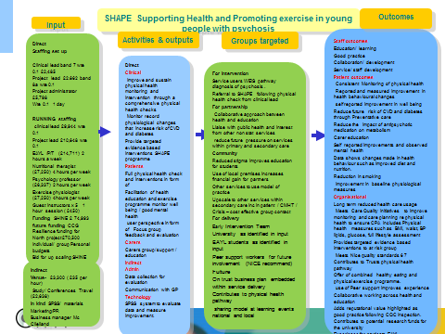

Appendix 5: Focus Group Further Quotes

Focus group evaluations were conducted during programme week 12 and programme feedback is collected weekly. Data from the focus groups has been subjected to thematic analysis, with a ‘constant comparison’ of themes across the cohorts. Evaluation themes included:

- Getting Started: social support; why not! (nothing to lose, feelings prior to attending); motivation; volition; and normalising (feeling normal).
“…when people started to talk to me, and I started to talk back to them, it was easier because I felt like I’d made a friend, and then more friends, and it was easier than just being on your own, because you felt like you were going with somebody.”
“It’s more of a relaxed environment here I guess, because it’s not as busy as some gyms can be. It’s a bit smaller as well. You’re in control of what you’re doing, and it’s just a good experience.”
“you kind of got to know people better, and then you kind of synced up with the same person so you had regular contact with a regular person which was nice.”

- Why not! (nothing to lose, feelings prior to attending)
“I was a lot more unstable to start with, as the programmes gone on my mood has become more stable and I think that my motivation has got better because before I … just sat in my room at home”

“It’s fun, it’s worthwhile doing, you make friends, it gets you fit, helps with your motivation.
“sometimes, for someone with psychosis or schizophrenia, sometimes it can be difficult to cope.”
“I didn’t feel well, but I thought I should go as it’s the last week, and I thought maybe I’d sit out and not do anything but actually I did some stuff, and I felt better afterwards.”
“ I quite liked how it structured my day, because before, I would find a way that I could not do anything, so it’s something that you feel like you’ve accomplished something after coming and that’s good for my self-esteem”.
“I still check my step counter all the time…now I quite like to cycle down the road lock it at the hive then walk the rest of the way into town “
“After the first week of doing it, I wanted to keep doing it, to keep helping me”
“…and once I’ve done the exercise, and I’ve done it, I feel loads better, like a weight has been lifted, it enables me to carry on for the day, for the rest of the week. It really motivates me, just by the fact that it lifts me. “
“there’s other people that come at the same time, so you don’t feel like you’re here for a specific activity, and there’s other people working out as well, so you feel like you’re in a normal environment.”
“Because it’s a Uni- it’s got that extra edge to it. All the students walking around, learning, smart.”
“it’s kind of just helpful that to see other people in your situation benefitting from the same things as you, it’s quite reassuring.”

- Maintenance: structured activities; gaining confidence; applying new knowledge
“Every week was different…It wasn’t the same old thing, it was very varied.”
“The books help that we’ve got. It was good because it was something else to focus on, and to try things that you wouldn’t ordinarily try.”
“The sessions have been worthwhile and I have gotten more fit and I have lost weight.” “I can walk quicker without losing breath. Before I’d have to walk slow.”
“I like the talking and nutrition parts. I also liked learning about drugs, I found it interesting.”
“ It has made me change my routine on other days as well. Before I wouldn’t want to go out or do anything, like walk my dog…whereas I’ve started doing it in the morning, then setting up my day with it, just to get that level of activity and to make me feel just a little bit better.”
“I just feel a bit like I have a bit more energy . I think my heart’s a lot healthier now because like before obviously smoking and not exercising for quite a while , I feel like my stamina is better”
“we try to get extra portions of vegetables into our meal, and find new, creative ways to incorporate them…and extra fruit and things like that.”
“because of the nutrition side of things, I’m trying to concentrate more on healthy eating and things.”
“I haven’t eaten less, but my waist circumference has gone down, and my BMI has gone down.”
- Feedback: programme feedback; family engagement; and support
“… on the initial day when you do the kind of tests…maybe you could say to the person what their goals are then because not everyone wants to just lose weight so like if I said I want to get stronger then maybe you could take arm measurements…instead of just saying you have gained or lost weight”
“it was always quite informal and … a relaxed laid back atmosphere when we were doing everything, nothing was said in a way of kind of dictator kind of a way it was kind of an open discussion on options we have over our lifestyle rather than like “you’re not eating this or you’re not eating that or get out and do that!” it was more of make your own decisions based on our recommendations…which was good.”
”There’s more structure around the book as well, they are quite handy. Some weeks we would use it and some we wouldn’t. I didn’t know if we had to use it as an activity book or if it was just there to help us.”
“Yes, saying how big the portion is, you only need a small amount where I thought you needed a lot. It just goes to show you just a small pile of beans or something is good enough as a meal rather than dumping the whole can on. Yes the nutrition ones were good.”
“the trouble is with SHAPE here, is that because it’s Worcester I have to travel quite a way to get here”.
“I actually used the gym probably for about half an hour longer. It seemed a bit too short”
“My dad said I’ve lost weight, he usually only says that if it’s true.
“My husband helped– we changed our diet together.”
“Yes, they can see how it’s helped me, it’s improved my confidence.”
Support worker quote:
“ I was extremely impressed with the SHAPE Project that I recently attended in the role of a Support Worker. The Project incorporated a wide variety of useful information and techniques, as well as introducing the attendees to different Sports and Health and Well Being Activities. The Content was excellent and totally relevant for everyone attending. The Staff involved in the Project were highly professional, knowledgeable and extremely kind and sensitive to the young men involved in the 12 week Project. Although the numbers attending were relatively low, I felt this was an advantage as this enabled the attendees to gain confidence and open up quite frankly about things. The Course ran with humour and dignity throughout. I know that the person who I came along with grew in confidence throughout and more importantly gained a friendship. This friendship has led to the two of them carrying on at the Gym and meeting up on a weekly basis. This is an outstanding result! Congratulations to everyone involved.”

