Executive summary

Caring for older people well, and with dignity, is not only our shared purpose but also our core business at Northumbria. One in three of our patients will have memory problems of some kind and our demographic profile means that the average age of patients occupying our medical beds, is 83 years old.

The intention behind our Dignity in Practice programme was to align the work of our corporate services in human resources and patient experience with the work of our clinical teams, and in doing so provide a ‘shared purpose ‘ and tangible response to the national directives for safe and compassionate care for older people.

We recognise that every member of our organisation has a part to play in delivering dignified, excellent care for older people. Our aims were innovative and deliberately ambitious.
Leadership for improvement
Our shared purpose programme of work was identified as one of 5 key organisational programmes within our Quality Strategy which has been important in helping to maintain a high profile within the Trust and provided strong leadership and support for the programme.
We worked hard to build and maintain relationships at various levels across the programme, using a variety of methods to engage key people.
Monthly Steering Groups helped to set direction and build momentum. Dial in and video links ensured participation across multiple hospital sites.

The project was supported by a team with skills and experience in quality improvement including a Health Foundation Generation Q Fellow as project lead and a project manager with an MSc in Leadership and Service Improvement.

Regular, face to face communication on the wards proved crucial in maintaining relationships with clinical staff. We also learnt the importance of measuring regularly and feeding this back to teams in real time.

What we did
We sought to understand more about the barriers to dignified care and the learning needs of our staff. We wanted to prioritise and promote local education initiatives to ensure our workforce, environments and clinical care promoted dignity and compassion in practice.
We devised a number of interventions aimed at influencing three key areas 1) the climate of care 2) supporting and developing our workforce and 3) improving the care experience for our patients.
Within these areas, we chose 10 interventions to implement and test including:
- Piloting nutrition assistants to promote social eating on elderly wards
- Welcoming Age UK as advocates for older people, to independently observe care and feedback to staff on person centred behaviours
- Introducing a new measure of kindness and compassion to our existing patient experience measurement programme
- Providing 20 multi-disciplinary ward teams with training on ‘learning about the person’ and supporting them in then making improvements

Appendix 1 provides an infographic depicting all interventions piloted throughout the lifetime of the project.
Impact
Within this highly complex project, we have observed how the gains achieved within each strand of the programme, have not been stand alone improvements, but have instead aggregated to contribute to a ‘greater than the sum of the parts ’story of organisational change.

This belief is supported by exciting changes in our National Staff survey results, particularly in the % of staff who feel that high quality patient care is the number one priority of the trust. This has risen from 43% in 2007, 86% in 2015.
The latest results were achieved with an 78% response rate; the second highest in the country.
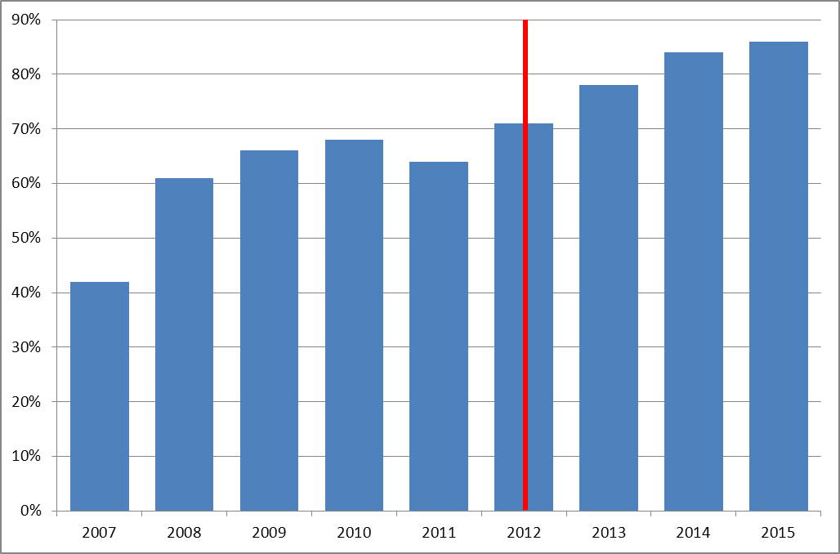

National staff survey data 2007 - 2015

You cannot make things happen, but you can create a space in which what you want is more likely to happen”

– Chinese proverb

A recent independent inspection from the CQC has rated Northumbria as outstanding across each of its 11 sites with regards to caring behaviours, the provision of high quality, responsive care and the quality of leadership at all levels of the organisation. It is the most positive CQC report published to date – with number one of only 4 organisations to attain this rating so far.
Staff spoke with excellent awareness of the Shared Purpose work which made inspectors believe that person centred behaviours were truly embedded in the Trust.

- “The “Northumbria Way”, which incorporates the trust’s values, behaviours and culture, was evident when we spoke with managers and staff throughout the trust…”

- “We found many examples of staff delivering compassionate care, which was polite and respectful. It was evident that staff went out of their way to overcome obstacles to ensure this. All patient feedback was extremely positive ….”

- “We observed a commitment to providing care that was of a consistently high standard and focused on meeting the emotional, spiritual and psychological needs of patients as well as their physical needs. There was a strong visible person-centred culture within the trust “

- “The trust had developed a Shared Purpose programme in partnership with a national charity to improve compassionate and dignified care for older people. This has resulted in the recruitment of nutritional assistants to support elderly patients, increased staff training and improvements in facilities and the ward environments across the trust for patients living with dementia...”

CQC Inspectors – October 2015.

Shining a light on kindness and compassion and regularly providing teams with feedback on how they are doing has encouraged novel ideas to improve care inspired by the frontline e.g. Our Singing Sensations – volunteers who entertain and create healing environments through music, the nursing assistant who hand knitted a poppy for each patient on Remembrance Day, to the ward team who have introduced hourly intentional rounding and have statistically reduced falls as a result.

We have seen a significant return in investment through promoting sociable eating and wellbeing. Our pilot of nutrition assistant 5 days a week, we have seen not only a significant difference in the number of patients who gain weight whilst on that ward, but also a statistically significant reduction in length of stay by on average 8.8 days per patient as a result – a potential cost saving of just under £800K in one financial year. (Appendix 7)
Over 200 multidisciplinary staff have benefitted from our Learning about the Patient Programme. Feedback with a 82% response rate is outstanding with most staff reporting highly significant changes in beliefs, behaviours and confidence about meeting the needs of people with dementia and delirium.
The statistically significant shifts against each of the key learning outcomes is illustrated in appendix 8.
The % of our patients readmitted following Total Hip Surgery and Total Knee Surgery has halved from 7.6% to 3.8% - a highly significant change (p=0.001) . Introduction of an orthopaedic helpline, wound clinics and improved patient information has helped us to ensure patients are fully involved and informed throughout their surgery and recovery.
(Appendix 9)
Above all Shared Purpose has achieved what it set out to do – it has delivered dignity in practice. Since the start of the programme in 2012 we have seen a statistically significant improvement (+10%) in the number of our patients who have reported always been treated with dignity and respect. This is externally validated data that is captured annually through the national patient survey.
The following chart illustrates Northumbria’s dignity data for the last 10 years and compares this with the national average. In line with our Shared Purpose interventions, special cause variation is evident from 2013 onwards – the latest results for 2015 showing a further rise with 92% of our patients reporting that they were always treated with respect and dignity by all staff involved in their care.
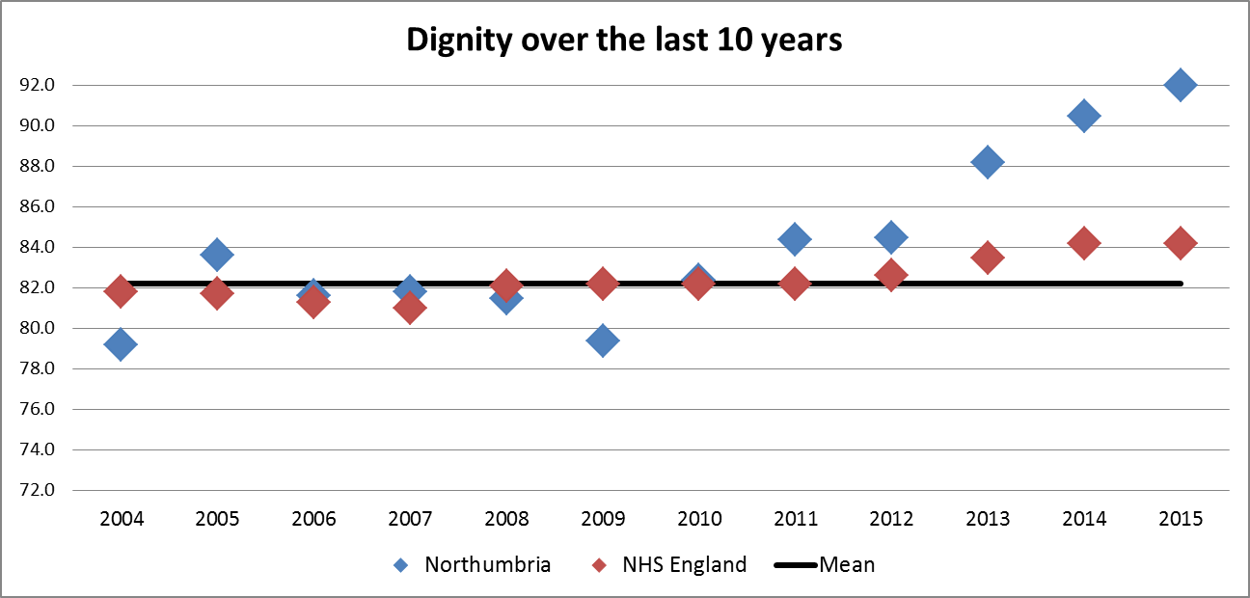
National Inpatient Survey Data 2004 - 2015

Sustainability and Spread
We used the NHS Institute’s model for sustainability and spread to focus our improvement efforts in three key areas: process, staff and what matters to the organisation.
The infographic in appendix 10 provides a summary of what has been done already to ensure interventions are sustained.
We have taken every opportunity to share our learning and resources widely. Appendix 11 shows some examples of how we have done this.
This improvement programme gave us the means to shine a light on compassion and celebrate everyday heroes –it has been a privilege to unearth their stories. We have enjoyed celebrating success and unearthing small acts of kindness that make all the difference to patients.

We believe that these stories have created a sense of joy and pride at work. Noticing; celebrating and experiencing compassion encourages us all to feel good and makes us want to repeat the experience – so a self-perpetuating cycle can begin.

We have also seen how our own stories have resonated with others beyond our own organisation:
http://www.emmamaynard.com/emmamaynardblog/2015/2/14/storytelling-is-the-most-powerful-communications-tool-you-have

Our sense is that Northumbria’s appetite for understanding and demonstrating the importance of kindness will only grow with time.

Shared Purpose has felt very different for us – less of a project to improve care and more of a cultural change programme and means of continually discovering who we are as an organisation and what we want to pay attention to in order to provide high quality, safe, continually improving and compassionate care.
We have illustrated these key priorities by means of a continuous ‘virtuous circle’ see below
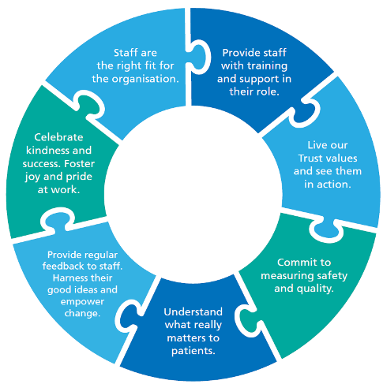

The link to our Shared Purpose film can be found in Appendix 12

