www.northumbria.nhs.uk
Dignity in practice: Our shared purpose to providing safe, compassionate and dignified care to older people

Supporting information: Appendices 1-12

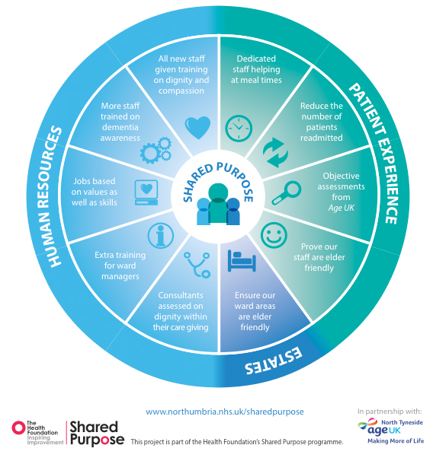
Appendix 1: High level summary of interventions, driver diagram and outcomes table
By 2015 the work of our corporate services will be aligned with the work of our clinical teams with a shared purpose of providing dignified compassionate care to frail older people
Organisational infrastructure, culture and values support the delivery of dignified and compassionate care.
An improved care experience for older people.
AIM
Primary Drivers
Secondary drivers
The ward environment is safe, ‘elder friendly’, continually improving and promotes health and wellbeing.
Nutrition and mealtimes for the frail elderly population are prioritised and supported with dedicated resources

Independent observation and capture of dignified and compassionate care for those unable to contribute to conventional patient experience surveys

Improved dementia resources and information for patients, staff and families

Patient feedback of outpatient services demonstrates improved collaborative partnerships with results are shared within Consultant appraisals.
Leadership development: Ward managers identify the support and skills they need to ensure their teams provide dignified compassionate care

Staff are informed and involved in agreeing ward priorities to improve care for older people which are linked to organisational values
Multidisciplinary teams feel equipped to recognise and respond to the needs of people with dementia and delirium
Better access to information and support for older people to combat isolation and avoid unnecessary admissions following orthopaedic surgery.
Dignified, compassionate care is everyone’s responsibility – induction provides an upfront message for all new staff that dignified care of older people is a strategic priority for the Trust which underpins all operational activity.
Compassionate and caring staff are recruited using values based interviewing.
Staff feel able to provide dignified, compassionate care by feeling well cared for and supported themselves.
Outcome
1
4
2
9
3
4
5
9
10
7
6
8
Staff are appropriately trained and supported to meet the needs of older people.
Appendix 2: Driver Diagram
Outcome | Secondary Driver | Key Results
1 | Recruiting for values | 725 managers have been trained in Values Based Interviewing and more than 4200 members of staff have been recruited in this way. Managers report that staff are ‘right fit’ for their teams and the organisation.
2 | Trust induction | Over 4000 members of staff have been through our new Induction where upfront messages on dignity and compassion are given. Focus groups show these messages are retained and reinforced by being in the organisation for 12 months.
3 | Learning about the person training | 20 multi-disciplinary teams have been through our learning about the person training programme and report statistically significant shifts in levels of understanding and confidence in delivering dignified, compassionate care to frail older people – particularly those with dementia and/or delirium. Changes to environments, practice and routines followed training and staff have been observed delivering compassionate care.
4 | Support for ward managers | Ward managers who have been on our mindfulness and resilience training course demonstrate statistically significant improvements to concentration at work, managing their workload and feeling capable.
5 | Patient experience fed into consultant appraisals | Patients are asked to comment on how their consultant performed in relation to compassion and dignity with results showing statistically significant improvements over a three year period.
6 | Reduction in orthopaedic readmissions | The % of our patients readmitted following Total Hip Surgery and Total Knee Surgery has improved by 32.6% and 78.8% respectively. Introduction of an orthopaedic helpline, wound clinics and improved patient information has helped us to ensure patients are fully involved and informed throughout their surgery and recovery.
7 | Observational visits by Age UK as advocates for older people | Eight shared purpose wards have had three visits from Age UK observational volunteers and were given immediate feedback. This has provided the opportunity to shine a light on small acts of kindness and celebrate staff, whilst also recognising opportunities for improvements.
8 | Development of web based resource on dementia | Development of a web based resource on dementia has improved information, learning resources and support for people living with dementia and their family/carers.
9 | Ensuring our wards and staff are elder friendly | Regularly sharing safety data and staff and patient experience has let us work with ward teams to set key improvement objectives and share and celebrate successes. In April 2014 we introduced measures for kindness & compassion as part of our patient experience programme. In 2015 0ver 10,000 patients gave an average score of 98.5% for always being treated with kindness and compassion.
10 | Pilot of nutrition assistants on elderly medicine wards | Piloting nutrition assistants on 2 wards with a high population of frail, elderly patients has shown that patients are statistically significantly more likely to gain weight with a nutrition assistant in post. This has also shown a positive correlation to a reduction in length of stay, suggesting patients are getting better quicker. The introduction of weekly snack clubs, reminiscence sessions over cake, singing groups and tea parties has improved staff and patient experience and relationships with families. Annual savings of £800k for one ward.

Appendix 3: What we did
Appendix 4: Impact
The impact of using both data and stories to measure change has felt very real for us and we have taken every opportunity to celebrate examples of small acts of kindness. Illustrative examples combined with data have helped us to tell a new organisational story and to foster joy and pride at work.

“Fostering the never ending desire to improve requires social support that appreciates the creativity, the discipline, the courage and the satisfaction from changing your own work” –

- Paul Batalden (2010) “The leader’s work in the improvement of healthcare”
Appendix 5: Values Based Recruitment

Our Trust Values were identified through staff surveys and focus groups. The rationale to then develop a framework for Values Based Recruitment was based on a number of factors, including as seeoverall aims of the Shared Purpose programme. Staff whose values are more clearly aligned with that of their employer, and whose roles allow them to live out these values, have been shown to have higher levels of engagement, job satisfaction and performance (MacLeod report 2009).

This linked to research by West and Dawson (2012) which shows the following correlations:

- Patient satisfaction significantly higher in trusts with higher levels of employee engagement
- Higher ratings linked to health and well being
- High engagement leads to lower absenteeism

A framework for Values Based Interviewing was designed by firstly working with job holders and managers to establish key competencies and aligned (positive) and non-aligned (negative) behaviours associated with each competency and value. Below is an example of a question relating to the value ‘respect’, which would be scored according to the aligned and non-aligned behaviours in the table underneath the question.

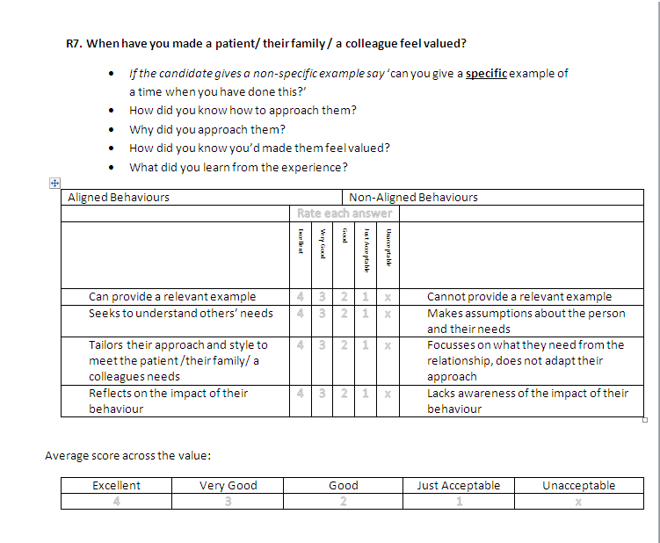
Question banks were formed under the following categories to pilot the model:

Over 700 recruiting managers within the Trust have now attended Values Based Recruitment training and over 2000 roles have been recruited to using VBR since January 2014.

The VBR team recently circulated a questionnaire and held focus groups with recruiting managers at the Trust, to gain feedback on their experience of using VBR since its introduction at the beginning of 2014. The feedback was largely positive and managers felt that recruiting staff based on the Trust Values is the ‘right thing to do’.
Feedback from managers and interviewees:
“I found the interview style excellent as it gave me the opportunity to tell a story about projects I have worked on in the past. Unlike other interview techniques, this way of interviewing gave me the opportunity to explain how I work by providing actual examples. It made the interview process enjoyable.”

“As the interviewer VBR is an excellent way of really understanding the person you are interviewing. The story telling doesn’t just allow you to measure their experience and knowledge, it provides you with an insight into who the person really is. It is a patient –centred approach to interviewing!”

“I have used the value based recruitment on three occasions now and I am a fan.
The conversational approach is friendlier and seemed to put the candidates at ease. Asking questions, which candidates can answer from any walk of their life, does reveal the real true values of the person.
I did at first find the technique more tiring for the panel so for subsequent interview sessions our team decided to have an extra person, not on the panel, but there to help with scribing. Recording the candidate’s answers verbatim is a task in itself.
It seems a strange thing to say but I found the VBR style was easier when deciding not to appoint in the first instance. This was the case when I first used the method.
Our first choice and highest point scorer turned us down so using the old method we would have selected the second highest point scorer. Using the VBR we were more aware of the true values that the candidates held. It meant going back to the recruitment and selection process again but we have since appointed the right candidate in the right post.”

Early Findings

The Trust’s organisational psychology team conducted some early evaluation of VBR by both analysing candidates reaction to the process and following up with recruiting managers to test predictive validity of the process.

The table overleaf shows the results of candidates reactions to the process. Candidates were asked to identify how much they agreed with statements about the process on a scale of 1-5 (1 being strong disagree, 5 being strongly agree). Both successful and unsuccessful candidates were asked to provide feedback.

The results above seem to support verbal feedback that the process puts candidates at ease and allows them to tell their story, whilst remaining clearly relevant to the post applied for.

In order to test predictive validity of the process, we followed up with line managers in December 2014, 6 months after members of their team had been successfully recruited via a values based interview. 23 line managers provided feedback (a response rate of 32.8%). Posts included secretaries, physiotherapists, nursing assistants, Staff Nurses, a Specialist Nurse, Clinical Psychologist, OT, and a Biomedical Scientist.

We asked these managers to rate the team members according to their performance, contribution to patients/ the department and on how well they have settled into the team, again on a scale of 1-5 (1 being unacceptable, 5 being excellent). The results were as follows:

  - Rating of performance = 4.10 (SD= .69)
  - Rating of contribution to patients/ the dept = 4.13 (SD= .59)
  - Rating of how well they have settled in = 4.52 (SD= .59)

As can be seen from the results above, line managers generally rated the staff members as very good or excellent in the three categories. The score of 4.52 for how well staff have settled into the department is promising and would support that VBR is helping us to recruit staff who are the right fit for the organisation.
Appendix 6: Comparing 2011 consultant performance with 2015

Did you have enough time to discuss your health or medical problem with the doctor?
 |  | Year |  | Total
 |  | 2011 | 2013
Did you have enough time to discuss your health or medical problem with the doctor? | Yes definitely | 87.0% | 89.7% | 88.1%
 | Yes to some extent | 11.5% | 9.2% | 10.6%
 | No | 1.5% | 1.0% | 1.3%
Total |  | 100.0% | 100.0% | 100.0%

Chi-Square Tests
 | Value | df | Asymp. Sig. (2-sided)
Pearson Chi-Square | 16.487ª | 2 | .000
Likelihood Ratio | 16.760 | 2 | .000
Linear-by-Linear Association | 16.293 | 1 | .000
N of Valid Cases | 9437
Did the doctor seem aware of your medical history?
 |  | Year |  | Total
 |  | 2011 | 2013
Did the doctor seem aware of your medical history? | He/she knew enough | 89.2% | 90.5% | 89.8%
 | He/she knew something but not enough | 8.4% | 7.7% | 8.1%
 | He/she knew little or nothing | 2.4% | 1.8% | 2.1%
Total |  | 100.0% | 100.0% | 100.0%

Chi-Square Tests
 | Value | df | Asymp. Sig. (2-sided)
Pearson Chi-Square | 6.073ª | 2 | .048
Likelihood Ratio | 6.186 | 2 | .045
Linear-by-Linear Association | 5.707 | 1 | .017
N of Valid Cases | 9127

Did the doctor listen to what you had to say? *
 |  | Year |  | Total
 |  | 2011 | 2013
Did the doctor listen to what you had to say? | Yes definitely | 90.5% | 91.8% | 91.0%
 | Yes to some extent | 8.6% | 7.7% | 8.3%
 | No | .8% | .5% | .7%
Total |  | 100.0% | 100.0% | 100.0%

Chi-Square Tests
 | Value | df | Asymp. Sig. (2-sided)
Pearson Chi-Square | 5.393ª | 2 | .067
Likelihood Ratio | 5.489 | 2 | .064
Linear-by-Linear Association | 5.178 | 1 | .023
N of Valid Cases | 9404

If you had important questions to ask the doctor, did you get answers that you could understand?

 |  | Year |  | Total
 |  | 2011 | 2013
If you had important questions to ask the doctor, did you get answers that you could understand? | Yes definitely | 82.6% | 83.1% | 82.8%
 | Yes to some extent | 16.3% | 16.0% | 16.1%
 | No | 1.2% | .9% | 1.1%
Total |  | 100.0% | 100.0% | 100.0%

Chi-Square Tests
 | Value | df | Asymp. Sig. (2-sided)
Pearson Chi-Square | 1.262ª | 2 | .532
Likelihood Ratio | 1.280 | 2 | .527
Linear-by-Linear Association | .694 | 1 | .405
N of Valid Cases | 8248
Did the doctor explain the reasons for any treatment or action in a way you could understand?
 |  | Year |  | Total
 |  | 2011 | 2013
Did the doctor explain the reasons for any treatment or action in a way you could understand? | Yes definitely | 87.4% | 88.2% | 87.7%
 | Yes to some extent | 11.4% | 10.7% | 11.1%
 | No | 1.2% | 1.1% | 1.1%
Total |  | 100.0% | 100.0% | 100.0%

Chi-Square Tests
 | Value | df | Asymp. Sig. (2-sided)
Pearson Chi-Square | 1.258ª | 2 | .533
Likelihood Ratio | 1.262 | 2 | .532
Linear-by-Linear Association | 1.208 | 1 | .272
N of Valid Cases | 8961
Did you have confidence and trust in the doctor examining and treating you?

 |  |  | Year |  |  |  | Total
 |  |  | 2011 |  | 2013
Did you have confidence and trust in the doctor examining and treating you? | Yes definitely |  | 91.5% |  | 93.0% |  | 92.1%
 | Yes to some extent |  | 7.1% |  | 5.8% |  | 6.6%
 | No |  | 1.4% |  | 1.3% |  | 1.3%
Total |  |  | 100.0% |  | 100.0% |  | 100.0%
Chi-Square Tests
 | Value | df |  | Asymp. Sig. (2-sided)
Pearson Chi-Square | 7.090ª | 2 |  | .029
Likelihood Ratio | 7.182 | 2 |  | .028
Linear-by-Linear Association | 5.557 | 1 |  | .018
N of Valid Cases | 9408

Was the reason you went to the Outpatient Department dealt with to your satisfaction?
 |  | Year |  | Total
 |  | 2011 | 2013
Was the reason you went to the Outpatient Department dealt with to your satisfaction? | Yes completely | 84.2% | 85.3% | 84.6%
 | Yes to some extent | 13.1% | 12.9% | 13.1%
 | No | 2.7% | 1.8% | 2.3%
Total |  | 100.0% | 100.0% | 100.0%

Chi-Square Tests
 | Value | df | Asymp. Sig. (2-sided)
Pearson Chi-Square | 7.893ª | 2 | .019
Likelihood Ratio | 8.130 | 2 | .017
Linear-by-Linear Association | 4.397 | 1 | .036
N of Valid Cases | 9425

2012 v 2014
 | 2012 | 2014
Q6 Doctor enough time | 92.9 | 94.1 |  | Sig improvement
Q7 Doctor aware medical history | 93.9 | 94.5 |  | No change
Q8 Doctor listen | 95.0 | 96.1 |  | Sig improvement
Q9 Doctor answer questions | 90.6 | 91.7 |  | Sig improvement
Q10 Doctor explain reasons for action | 93.0 | 94.3 |  | Sig improvement
Q11 Confidence and Trust Doctor | 95.1 | 96.1 |  | Sig improvement
Q31 Reason for OP appointment dealt with | 90.9 | 91.6 |  | No change
Overall Score | 93.7 | 94.5 |  | Sig improvement

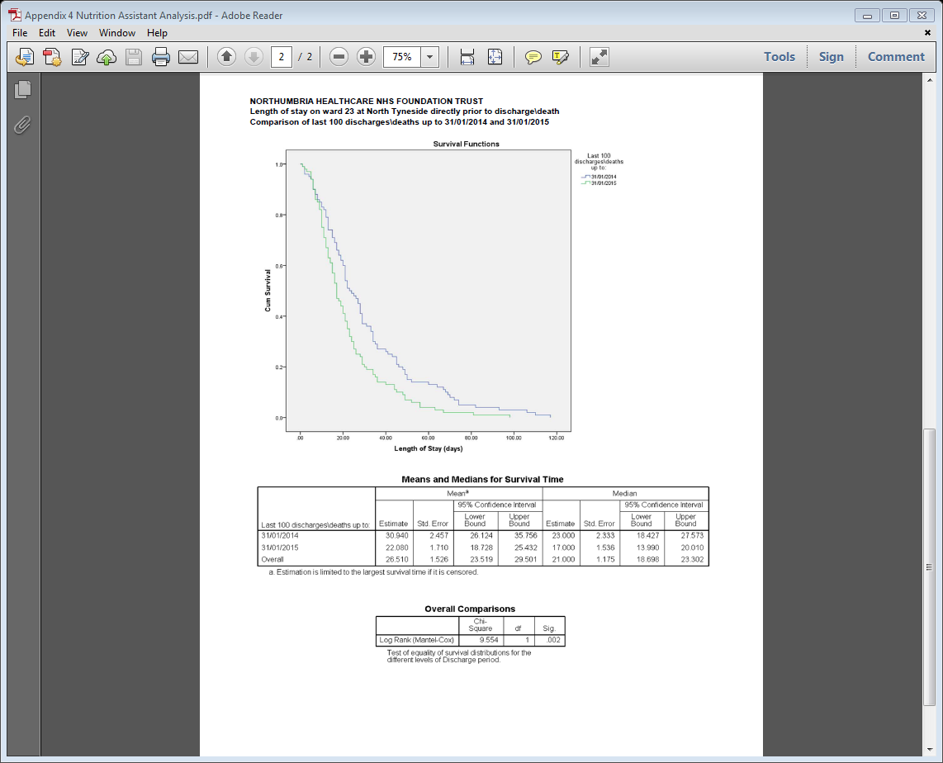
Appendix 7: Statistically significant nutrition assistant analysis

Appendix 8: Learning about the person programme evaluation
PROBLEM SCORES |  |  | SAMPLE SIZE |  |  |  | SIG?
(PRE)  Problem Score(p1) | (POST)  Problem Score (p2) |  | (PRE) Sample Size (n1) | (POST)  Sample Size (n2) |  | t-value | **If t-value is greater than 1.96 or more negative than -1.96, the result IS significant. (95% confidence).  **If the t-value is less than 1.96 or less negative than -1.96 the result is NOT significant. (95% confidence).
Q1) 12 | 82 |  | 184 | 185 |  | -18.90 | Post Significantly BETTER than pre
Q2) 16 | 89 |  | 187 | 184 |  | -20.64 | Post Significantly BETTER than pre
Q3) 8 | 99 |  | 187 | 183 |  | -43.01 | Post Significantly BETTER than pre
Q4) 13 | 91 |  | 186 | 182 |  | -23.98 | Post Significantly BETTER than pre
Q5) 9 | 62 |  | 179 | 184 |  | -12.71 | Post Significantly BETTER than pre
Q6) 10 | 87 |  | 187 | 185 |  | -23.29 | Post Significantly BETTER than pre
Q7) 21 | 100 |  | 186 | 186 |  | -26.45 | Post Significantly BETTER than pre
Q8) 4 | 47 |  | 187 | 184 |  | -10.89 | Post Significantly BETTER than pre

Appendix 9: Orthopaedic readmission data

We carried out a basic Chi square significance test comparing proportion of patients readmitted within 30 days in two groups. Chi square p value <0.001 Group one was for patients who had surgery between Jan 2008 and August 2012. (6,928 patients not readmitted (92.4%), 568 patients readmitted (7.6%) - total 7,496 patients) Group two was for patients who had surgery between Jan 2013 to present. (6,569 patients not readmitted (96.2%), 257 patients readmitted (3.8%) - total 6,826 patients)

We also carried out a binary logistic regression model with 30 day readmission as the outcome variable. The “intervention” defined as a predictor by defining pre intervention as Jan’08 to Aug’12 and post-intervention as Jan’13 to present.

Total Hip Replacement
Total Knee Replacement
Appendix 10: Sustainability
Appendix 11: Spread and adoption
Appendix 12: Shared purpose: A virtuous circle

The importance of connecting our staff experience and patient experience, and showing compassion to one another has been reinforced for us throughout the project. We created a visual ‘virtuous circle’, below, which summaries how aligning human resources and patient experience to clinical teams has helped us on our journey towards a shared purpose of delivering dignified, respectful and compassionate care.

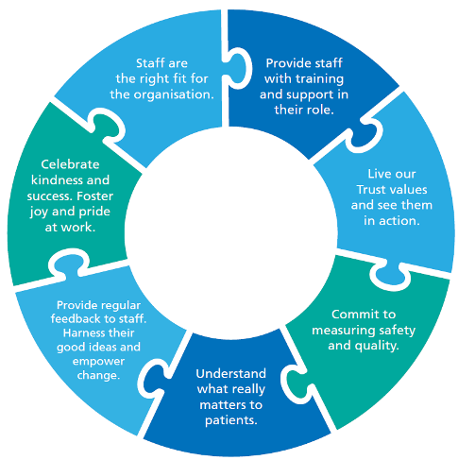

Please click here to access the Northumbria Healthcare - Shared Purpose video.

