Shine 2014 final report
Development and Evaluation of a First Episode and Rapid Early Intervention Service for Eating Disorders (FREED)
South London and Maudsley NHS Foundation Trust
September 2015

The Health Foundation
Tel 020 7257 8000
www.health.org.uk

Part 1: Abstract

Project title: Development and Evaluation of a First Episode and Rapid Early Intervention Service for Eating Disorders (FREED)

Lead organisation: South London and Maudsley NHS Foundation Trust

Partner organisation: Institute of Psychiatry, Psychology and Neuroscience, King’s College London

Lead Clinician: Danielle Glennon

The Problem
Eating Disorders (ED) are severe mental disorders with a peak onset in adolescence / early adulthood. Early effective intervention within ~ 3 years of onset is essential to prevent ED becoming chronic and treatment-refractory.

A key barrier to early effective treatment is poor access to services. A survey of young ED sufferers by the charity Beat (2013) showed that: 30% had to wait > 18 weeks and another 34% had to wait > 6 months to access care. 74% said their ED got significantly worse whilst they were waiting for treatment. Research has shown that waiting for treatment disempowers patients, and reduces engagement with and responsiveness to subsequent treatment, and young patients are particularly vulnerable to this effect.

Intended Improvement
Available evidence provides a compelling case for reducing the duration of untreated eating disorder (DUED) (and wait-time as an important component of DUED) in young people with ED and providing early intervention.

Aims
To assess whether a novel First Episode and Rapid Early Intervention Service for young people with an ED (FREED) shortens DUED and waiting time and improves outcomes.

The Intervention and Why this is Innovative
We developed FREED for young people (aged 18-25) with short (<3years) first episode illness duration to overcome barriers to effective early treatment. This service is embedded in a large NHS specialist ED service for adults and is delivered by a multi-disciplinary team. FREED is innovative through its unique combination of a rapid screening & assessment protocol, evidence-based guided online & manualised self-help interventions for patients and carers, and an implementation tool-kit for staff and services.

Key Results and Impacts
Results
- FREED patients waited almost 40% less time for an assessment (63% when there were no funding delays) and waiting time for treatment was more than halved (69% when no funding delays) compared to matched audit data.
- All (100%) of the FREED patients took up treatment, compared with 87% from published data. Treatment dropout was 15%, compared to 20-44% from published data.
- Overall clinical improvement is rapid, with patients’ average eating disorder symptom at 6 months below the cut-off for a clinical eating disorder.
- Patient and carer satisfaction with FREED are high.
Impacts
Locally
- Several local NHS commissioners are now allowing direct referrals of young people from GPs to the EDU, in response to our findings.
- Our Trust have given us four additional staff members to sustain/expand FREED after the project.
Nationally
- FREED has been widely reported in the national media.
- FREED will be disseminated to other professionals at key national and international conferences.
- FREED was reported as an example of good practice in a 2015 NHS England Eating Disorders Commissioning Guide.
Key challenges and Learning
- Early intervention (i.e. reduced DUED and waiting times) are associated with improved outcomes and high levels of patient satisfaction.
- Funding delays contribute to longer DUED and waiting times.
- Further engagement with commissioners is key in making early intervention available to all young people with ED.
Part 2: Quality impact: outcomes

The FREED service includes a rapid screening and assessment protocol, which aims for patients to complete their assessment and start treatment within 1 month of referral. Once assessed, patients are rapidly allocated to an evidence-based treatment including individual therapy and guided online or manualised self-help interventions.

Development and implementation of the FREED service was managed by a working group within the ED team, which included senior staff members, a dedicated psychologist and research worker. During the pilot stage, FREED patients were screened, assessed and treated primarily by this working group. The integration phase followed, during which administrative and clinical responsibilities of the FREED service were transferred across the wider clinical team. Processes that facilitated this transition include: team training days, standing agenda item in weekly team meeting, and development of protocols which act as a ‘tool kit’ for staff. Changes to service procedures were regularly evaluated and adjusted through update meetings and monitoring of balancing measures (i.e., waiting times for non-FREED patients).

Our tests of change include process measures (i.e., waiting times) and clinical outcomes (i.e., ED psychopathology). We also elicited patients’ and carers experience through questionnaires and interviews.

Primary and secondary data used to demonstrate impact on quality

Primary data
FREED data were matched (on age and illness duration) to previous 2 year audit data.
- DUED: length of time between ED onset and the date patients attended their assessment.
- Waiting times for assessment and treatment: time period from GP referral to the date patients attended for their assessment and first treatment session.
Secondary outcomes
- Engagement: treatment up-take and drop-out rates (i.e. treatment discontinued against clinician recommendations) compared to existing literature.
- Clinical measures: ED and other mental health outcomes were measured at start of treatment, 3 months and 6 months (12 months still to be collected).
- Patient satisfaction and experience: evaluated via questionnaires and semi-structured interviews.
a) Adjustments to outcome measures: originally our main focus was on clinical outcomes (i.e. ED psychopathology). However, due to project time constraints the primary focus was redirected to DUED and waiting times. Exploration of clinical outcomes is ongoing.

b) Source of data and how easy it was to access:
- FREED data: collected by research worker with high rates of completion.
- Audit data: some issues related to inconsistencies in record keeping.
c) Validity and reliability of the data: The FREED data relating to DUED and waiting times are valid and reliable; dates of referrals, assessment and treatment were recorded accurately throughout the study. ED onset was determined with a retrospective life chart with anchors, an approach that has been validated in other studies. All questionnaires used to assess clinical outcomes are validated. In regards to the audit data, inconsistencies in record keeping are likely to have somewhat impeded its validity and reliability.

d) Baseline data quality: 30% (62/201) of referred patients between the age of 18-25 were eligible for FREED (compared to 25% in the matched audit data) and 60 were recruited

See appendix 2 for a CONSORT diagram with a detailed account of patient flow and analyses. Appendix 3 gives baseline demographic information.

Primary outcomes (excludes 9 FREED pilot cases, n=51)
The FREED service reduced DUED in comparison to both audit data and published data (DUED of 1.8 and 2.1 years) [2, 3]. This improvement was even more pronounced in those with immediate funding (<1 week).

 | Matched audit data (N=89) | FREED cohort (N=51) | FREED – immediate funding (n=14) | FREED – delayed funding (n=37)
DUED | 16 months | 15 months | 12 months | 16 months
Wait for assessment | 10.0 weeks | 6.4 weeks** | 3.7 weeks | 7.5 weeks
Wait for treatment | 19.8 weeks | 9.6 weeks** | 6.2 weeks | 10.9 weeks
** p < .001

Secondary Outcomes (entire FREED cohort included, N=60)

Treatment uptake and drop-out
FREED had 100% treatment up-take (i.e. all patients who were offered treatment started it), which is higher than rates reported elsewhere (e.g., 87%) [4]. 15% of FREED patients dropped out of treatment (9/60), this is lower than previously reported rates of between 20 – 43.7% [4, 5].

Clinical outcomes
We measured clinical outcomes at the start of treatment, at 3 months and at 6 months (12 month data still to be collected). At baseline 17% (9/53) had an EDE-Q global score < 2.8 below the clinical cut-off. This rose to 38% (11/29) at 3 months and 56% (9/16) at 6 months follow up. Moreover, we observed improvements in scores on measures of general psychopathology with large effect sizes.

 | Start  M(SD) n=53 | 3-months  M(SD) n=29 | 6-months  M(SD) n=16 | Effect size (d) start – 6months
EDE-Q global score | 4.05 (1.29) | 3.12 (1.36) | 2.41 (1.25) | 1.29
DASS-depression | 11.69 (5.58) | 8.62 (6.13) | 5.62 (3.83) | 1.29
DASS-anxiety | 8.38 (4.98) | 5.96 (5.06) | 5.00 (4.47) | 0.71
DASS-stress | 12.04 (5.32) | 9.89 (6.17) | 8.00 (4.60) | 0.81
CORE-10 | 19.58 (7.99) | 15.96 (6.62) | 12.69 (4.84) | 1.07
WASA | 20.25 (9.52) | 17.64 (9.38) | 12.69 (4.84) | 1.05
CIA | 38.43 (11.89) | 30.78 (16.30) | 22.31 (12.30) | 1.33
LEE | 15.54 (11.91) | 14.33 (9.76) | 10.60 (6.03) | 0.55
Cut-off scores: Eating Disorder Examination – questionnaire (EDE-Q: >2.80 clinical severity; 21 item Depression, Anxiety and Stress Scale (DASS-21) depression 11-13 severe, 7-10 moderate, 5-6 mild; anxiety 8-9 severe, 6-7 moderate, 4-5 mild; stress 13-16 severe, 10-12 moderate, 8-9 mild; 10 item Clinical Outcomes in Routine Evaluation (CORE-10): >20 moderate-severe, 16-20 moderate, 11-15 mild, <11 non-clinical; Work and Social Adjustment Scale (WASA): >20 moderate-severe, 10-20 moderate, <10 non-clinical; Clinical Impairment Assessment (CIA): >16 ED case status; Level of Expressed Emotion (LEE) scale: no clinical score ranges available at present.

Preliminary analyses suggest that FREED helps AN patients (with BMI at assessment < 18.5kg/m²) improve weight.

 | Start of treatment  M (SD) n=22 | 3-months  M (SD) n=15 | 6-months  M (SD) n=8
Weight (kg) | 45.13 (4.89) | 46.13 (5.19) | 48.06 (5.04)
BMI (kg/m²) | 16.26 (1.62) | 16.40 (1.17) | 17.30 (1.47)

Patient satisfaction and experience
Average satisfaction with waiting times was 9.08 (n=17) and for the process of starting treatment was 9.15 (n=16) (0 ‘unsatisfactory’ to 10 ‘highly satisfactory’).

Quotes from interviews with FREED patients and carers highlight the importance of reduced waiting times and funding difficulties:
- “the referral process is really good… that it’s so quick”
- “it’s been good and helpful because she could have been still waiting and her situation could have been worse”
- “had my mum not called the commissioners up and said what’s happening they wouldn’t have put it through… they were sitting on it… and that day we got an email saying I had funding and could start treatment… its only because of my mum’s persistence… that’s a flaw in the system’

Impact against original intended outcomes

The FREED service has demonstrated a positive impact on the quality of patient experience and patient safety throughout the treatment journey - from referral to clinical outcomes. DUED was reduced by approximately 1 month (4 months when no funding delays). On average, a FREED patient waited almost 40% less time for an assessment (63% when no funding issues) and waiting time for treatment was more than halved (69% when no funding issues). Patient engagement with the FREED service was excellent: there was a 100% up-take of treatment (compared to rates of 87% reported elsewhere [4]) and drop-out rates were reduced by 25-35% (when comparing to previously published rates [4, 5]). Clinically significant reductions in psychopathology were observed across treatment on a range of psychometric measures (ED and general psychopathology). Crucially, at the 6 month point, the average score on the EDE-Q (the most widely used scale for ED psychopathology) was below the clinical cut off. Moreover, patients reported very high rates of satisfaction with the service.

Part 3: Cost impact

Key cost measures and our understanding of the financial impact of the project
Our key cost measure is the specialist eating disorders unit service utilisation cost of patients participating in FREED.

Service Utilisation Costs
We will be able to conduct a full analysis of the service utilisation costs after all FREED participants have completed their follow-up (i.e. 31st of August 2016). We will then have full data on specialist eating disorder unit (EDU) service utilisation (including number of treatment sessions attended, proportion of patients needing in-patient or day-care treatment) and will be able to compare this information against previous patient cohorts (audit data, clinical trial data) from our service. We will also be able to break down this information for different diagnostic groups (anorexia or bulimia nervosa).

We expect the number of treatment sessions attended to be similar or slightly higher in FREED than in comparison data, given better treatment uptake and lower treatment drop-out in this group. However, higher costs due to better session attendance might be offset by somewhat shorter treatments due to earlier recovery. To date 5 patients have completed treatment and these have averaged 20 treatment sessions.

How we estimated the cost of existing pathways / packages of care
Care options provided by the EDU are outlined in the Specialist Service directory of the South London and Maudsley NHS Trust (https://www.national.slam.nhs.uk/). Costs for these are as follows: clinical assessment: £355, outpatient sessions: £150, days in day-care £265 or days in in-patient treatment £491. These will form the basis for our cost-estimates.

Limitations
These costs do not include any patient visits to primary care during the study period or any other medical treatments/appointments that patients may have had.

How we have calculated the cost of the FREED intervention
The cost of the FREED intervention will combine the cost for the project lead funded by the Health Foundation (0.8 band 7 clinical psychologist; £42,544), the training costs for the Eating Disorders Team (including cost of trainers and team attendance for 1.5 days; total £ 9,300) and any excess treatment costs incurred by FREED patients over and above usual treatment costs by patients seen usually in our service.

Assuming that excess treatment costs are minimal or non-existent, the cost of setting up and running FREED per patient is: £864.

Limitations
We have not included the additional time given by project team members to the project, because most of this has focused on evaluation aspects of the project, report writing and preparing for Scaling Up, which are not FREED intervention costs.

We have not included broader illness related costs, e.g. buying binge foods, costs of laxatives. We also have not included societal costs e.g. due to patients’ reduced productivity or lost earnings (patient or family members, e.g. because of appointments attended or sickness leave).

Accounting for implementation costs
These costs are listed above under the costs of the Shine intervention.

Demonstration of cash-releasing saving from our project?
N/A

Part 4: Learning from the project

Achievements
To summarise overall, we achieved more than expected in this project in a number of areas. The project was set up and started on time and has run to expected time lines. As evidenced in Part 2, extremely positive improvements in quality of care, including reductions in DUED and waiting times, improvements in clinical outcomes and high levels of patient and carer satisfaction have been achieved. We were encouraged FREED did not lead to an increased assessment waiting list for Non-FREED patients, due to the additional SHINE funding. Due to the success of FREED, the department has expanded to reduce overall waiting times for all patients. In response to the project, we have updated service protocols and processes. Hugely important, the early success of the project has changed the commissioning structures of two boroughs to significantly speed up access to care and remove barriers to care. These improvements gave the team the confidence and data to apply for the Shine Scaling Up award. The project has also generated substantial excitement, both from peers within the field (invited to speak at conferences) and the media (Appendix 1).
Aspects that contributed to achievements include a good skill set mix within the core project team and being embedded within a team that is motivated, enthusiastic and research/ quality improvement ready; financial support and encouragement from Jane Hannon, Head of Pathways for Specialist Care within the Trust and support from Richard Edgeworth of Springfield Consultancy. More broadly, we are fortunate to be based in an NHS Trust that is forward thinking and innovative. A national focus on waiting times in Eating Disorder Services also highlighted the relevance of the project.

Challenges

The most significant and on-going challenge of the project is frequent changes and delays in commissioning based funding panels. At the beginning of the project we invited commissioners and GPs to an open day designed to launch the project, but none came. However, Project Lead, Danielle Glennon has worked tirelessly to engage commissioners, utilising positive media coverage and we are very pleased that two commissioning groups have streamlined their processes as a result.

We have encountered challenges in implementing changes to existing service administration processes including referral screening, assessment booking procedures and allocation of patients. We also recruited somewhat fewer patients than originally estimated; however, on analysis of previous audit data initial recruitment estimates were inflated.

As described in Part 2, a further challenge has been inconsistency in previous record keeping which has impacted on the retrospective audit data required for the comparison with the FREED data.

Specific learning on introducing and sustaining innovation in the NHS

Patients and carers were essential to highlight the value of FREED and we involved them at all stages (regular feedback; included in media events; Open days). To sustain FREED at a team level, we focused on regular team days, incorporating FREED into team life (sharing responsibilities, regular agenda item at meetings, FREED newsletter) and celebrating successes together and involving team in mini projects (e.g. development of social media guide).

To introduce and sustain at broader NHS level, we are developing a FREED service toolkit, including clear flowcharts, which make it easy for all to work with. We networked at Health Foundation Events and specific conferences. Finally we drew on learning from other fields (e.g. early intervention in psychosis).

Advice for a similar project

Key advice would be to keep the project manageable, and select a realistic goal. If it’s successful, this can be built on. Process based goals maybe more appropriate for fixed, short time periods. Attempt to involve commissioners from the beginning of the process. A weekly meeting with the core team was essential to ensure efficiency, clear planning and communication. Project ‘champions’ encouraged and supported the development and embedding of FREED. It is vital to have the direct care team and senior management staff on board with the project. This is a valuable learning opportunity, be open to new ideas and people and record all ideas and reflections.

Finally, we shifted the focus from clinical measures to process measures as a result of the short time frame of the project. This gave us very ‘real and relevant’ high impact data which were easy to share with commissioners and the media.

Part 5: Plans for sustainability and spread

FREED has been embedded in the service successfully and will continue within the service as a care pathway for young people aged 18-25 years old. New administration systems have been put in place, and much work has gone on with commissioners to try and streamline the referral process. The Trust have been impressed with the success of FREED and have supported our service to employ a further four members of the psychology team, therefore meaning that time can continue to be dedicated to FREED, and that other ‘non-FREED’ patients will also benefit from reduced waiting times..

The weekly referrals meeting will continue to ensure that FREED patients are captured. FREED champion in the department will continue and FREED patients will continue to be discussed and allocated within the weekly MDT meeting. Protected assessment slots for FREED patients will continue within the department.

In addition the FREED project has benefited non-FREED patients in that the social media guide and nutrition guide that have been compiled as part of FREED are available to all our patients.

We have made an application for The Health Foundations Scaling Up Project and are successfully through to the second round of the application. Our aim is to complete our toolkit and spread our innovation to other eating disorder services around the country using e.g. the Royal College of Psychiatrists Eating Disorders Faculty and the associated Eating Disorders Quality network (QED). We are also going to be making an application to the Health Foundation for Spreading Improvement funding, where we hope to put together an interactive website with video’s for young adults, carer’s, GP’s and commissioners to provide psycho-education to help shorten the length of untreated illness.

We have had much external interest from the media (see Appendix 1), and several other services are interested in adopting our care pathway for 18-25 year olds to reduce the length of untreated illness. Also through the media interest two of our seven commissioners have come on board with providing quick decisions for funding. Our aim is to continue the work with commissioners and we will have a meeting with all our seven commissioners (covering a local population of 2 million people) in November to discuss and agree a FREED care pathway using the evidence from this project.

Our team are also going to be presenting FREED at the Royal College of Psychiatrists’ Eating Disorder Faculty Annual Scientific Meeting in November 2015 and at the London Eating Disorders International Conference (EDIC) in March 2016. We have been shortlisted for The Royal College of Psychiatrists Psychiatric Team of the Year due to our innovations. FREED has also be named in NHS-England’s Commission Guide for Eating Disorders for Child and Adolescent Services as a model of best practice.

Appendix 1: Resources from the project

Please attach any leaflets, posters, presentations, media coverage, blogs etc you feel would be beneficial to share with others

Overview
- Leaflets and resources
  - FREED launch day invitation
  - FREED tool kit (contents page)
- Posters
- Presentations
  - Invited plenary talk presentation on FREED at the Royal College of Psychiatrists Eating Disorders Faculty Annual Scientific Meeting, London, Nov 2015.
  - Invited workshop presentation on FREED at the Eating Disorders International Conference, London March 2016.
- Media coverage
  - Mentioned in an article in the Guardian (14th June 2015)
  - Feature article in the Guardian (21st June 2015)
  - Mentioned in an article in the Independent (21st June 2015)
  - Interview with Prof Schmidt and a FREED patient on BBC Radio 4 Woman’s Hour (29th June 2015)
  - Interview with Dr Mountford on the Heath Today Radio program on (22nd July 2015)
  - The FREED service was cited as an example of best practice in NHS report on Eating Disorder Service (July 2015)
  - Mentioned in SLaM newsletter (August 2015)

Leaflets
FREED launch day invitation

FREED toolkit
Contents
Part I – Introduction to early intervention

Part II – Rationale for early intervention in eating disorders

Part III – Patients perspective
- Case stories

Part IV – Carers perspective
- Case stories

Part V – Clinician perspective & guide
- Staff stories working on FREED
- Guide to working with FREED patients & their carers

Part VI – Service Components
- Processes and timelines
- Health systems (i.e. the NHS, private treatment etc)
- Setting up the FREED service
  - Operational changes (e.g. FREED champions)
  - Assessment
  - Treatment
- Tips for administrators
- Impact on other aspects of service
- Adolescent perspective/transitions

Part VII – Commissioners Guide

Part VIII – Health Economics

Part IX – Resources for service users
- Social media information booklet
- Dietetic information booklet
- Preparing for university focus groups

Part X – New technologies

Part XI – Learning, sustaining & dissemination
- Website

Part XII – Conclusion & appendices
Posters
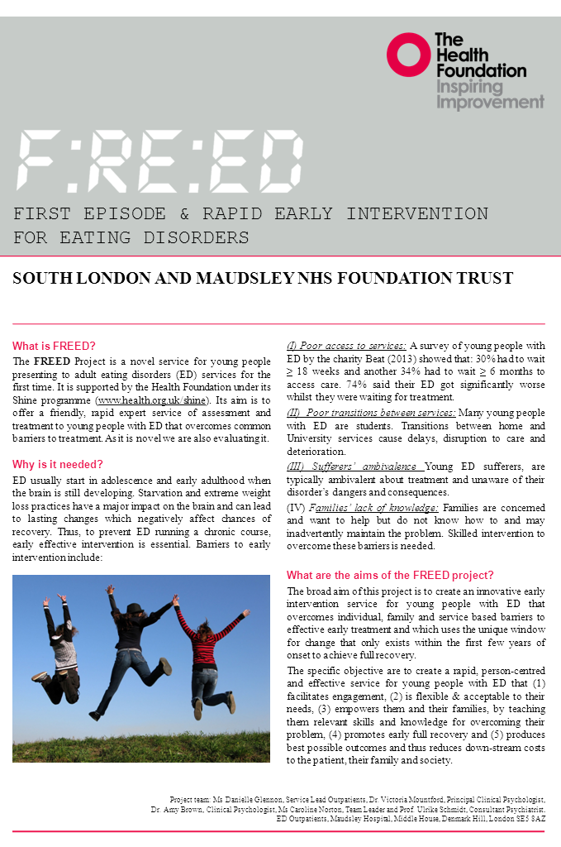

Media Coverage
Mentioned in an article in the Guardian (14th June 2015)
http://www.theguardian.com/society/2015/jun/14/eating-disorders-long-waits-nhs-treatment-lives-risk
Article in the Guardian (21st June 2015)
http://www.theguardian.com/society/2015/jun/21/eating-disorders-nhs-trial-anorexia-bulemia

Mentioned in an article in the Independent (21st June 2015)
http://www.independent.co.uk/voices/comment/i-spent-six-years-trying-to-recover-from-the-bulimia-i-developed-as-a-fifteen-year-old--with-earlier-intervention-it-all-could-have-been-avoided-10372373.html

Interview with Prof Schmidt and a FREED patient on BBC Radio 4 Woman’s Hour (29th June 2015)
http://www.bbc.co.uk/programmes/b0607w1l
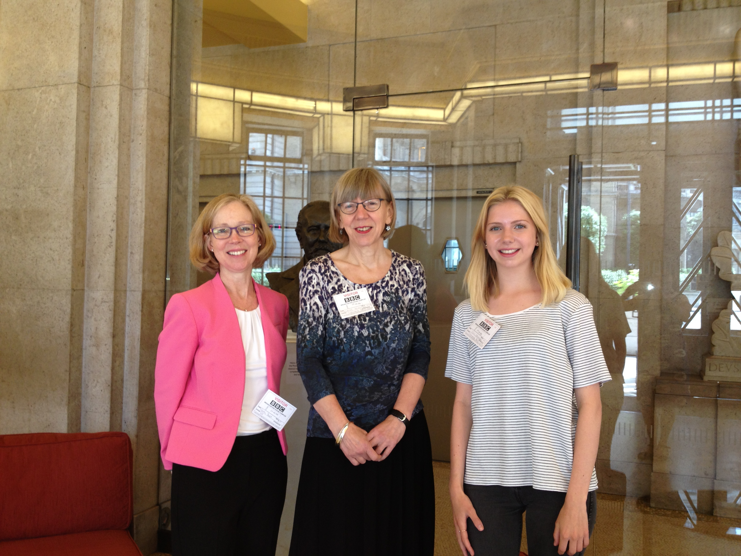

Interview with Dr Mountford on the Heath Today Radio program on (22nd July 2015)

http://www.nhs.uk/Conditions/health-today-radio/Pages/welcome.aspx

The FREED service was cited as an example of best practice in NHS report on Eating Disorder Service (July 2015)
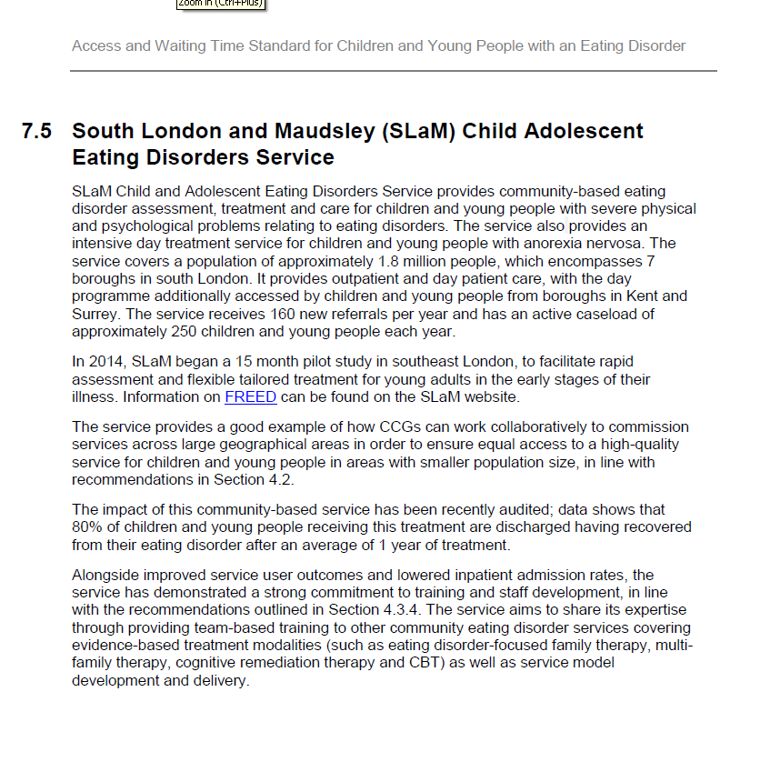

Mentioned in SLaM newsletter (August 2015)

Appendix 2 – CONSORT diagram
Patients between age 18 - 25 assessed during study period (n=201)

Treatment outcome analysis (n=60):
Baseline assessment: completed (n=53), awaiting (n=4), did not complete (n=3; 1 missing, 1 drop-out, 1 moved out of area)
3month assessment: completed (n=29), awaiting (n=17), did not complete (n=14; 9 drop-out, 3 moved out of area)
6month assessment: completed (n=16), awaiting (n=32), did not complete (n=12; 9 drop-out, 3 moved out of area))
:
Excluded (n=141), with reasons:
- Aged 18-25 but ED history > 3 years (n=95)
- Atypical ED/comorbid diagnosis (n=8)
- Funding not approved (n=3)
- No further contact (n=29)
- Other (n=6)
DUED & waiting time analysis (n=51):
Funding delays (i.e. > 1 week) for assessment (n=37)
Excluded (n=2), with reasons:
- moved out of area prior to assessment (n=1)
- no further contact (n=1)
Met inclusion criteria for FREED (age 18-25 and illness duration < 3 years) (n=62)
FREED cohort (n=60)
FREED pilot cases (referred prior to start of study, assessed during the study period) (n=9)
Immediate funding (i.e. < 1 week) for assessment (n=14)
Treatment Uptake and Adherence (n=60):
Offered Treatment following assessment: n=60
Took up treatment: n=60 (in-patient n =1, outpatient=59)
Completed treatment n=5
Dropped out from treatment: n=9
Moved out of area n=5
Currently still in treatment: n=41
Appendix 3 – Baseline demographic information

 |  | Audit data (n=89) | FREED cohort (n=60) | FREED with immediate funding (n=14) | FREED with funding delays (n=37)
Age on referral |  | 20.47 (1.99) | 20.39 (2.42) | 21.33 (3.05) | 20.37 (2.27)
Gender (F:M) |  | 87:2 | 58:2 | 13:1 | 36:1
Diagnosis
 | AN-restrictive | 28 (32%) | 19 (32%) | 5 (36%) | 10 (27%)
 | AN-binge/purge | 5 (6%) | 5 (8%) | - | 5 (13%)
 | BN-purging | 23 (26%) | 16 (27%) | 4 (29%) | 11 (30%)
 | BN-non purging | 2 (2%) | 3 (5%) | 1 (7%) | 1 (3%)
 | BED | 4 (4%) | 1 (2%) | - | -
 | EDNOS-AN | 17 (19%) | 8 (13%) | 3 (21%) | 5 (13%)
 | EDNOS-BN | 6 (7%) | 6 (10%) | - | 4 (11%)
 | EDNOS-other | 4 (4%) | 2 (3%) | 1 (7%) | 1 (3%)

References

1. Schmidt, U., et al., The Maudsley Outpatient Study of Treatments for Anorexia Nervosa and Related Conditions (MOSAIC): Comparison of the Maudsley Model of Anorexia Nervosa Treatment for Adults (MANTRA) With Specialist Supportive Clinical Management (SSCM) in Outpatients With Broadly Defined Anorexia Nervosa: A Randomized Controlled Trial. Journal of Consulting and Clinical Psychology, 2015. 83(4): p. 796-807.
2. Schoemaker, C., Does early intervention improve the prognosis in anorexia nervosa? A systematic review of the treatment-outcome literature. International Journal of Eating Disorders, 1997. 21(1): p. 1-15.
3. Neubauer, K., et al., Paths to first treatment and duration of untreated illness in anorexia nervosa: are there differences according to age of onset? European Eating Disorders Review, 2014. 22(4): p. 292-298.
4. Waller, G., et al., Problems across care pathways in specialist adult eating disorder services. Psychiatric Bulletin, 2009. 33(1): p. 26-29.
5. Dejong, H., H. Broadbent, and U. Schmidt, A systematic review of dropout from treatment in outpatients with anorexia nervosa. International Journal of Eating Disorders, 2012. 45(5): p. 635-47.

